How do food molecules reach our muscles?
– Structure and Function of Organ Systems, Organs and Cells

We all know that food nourishes our muscles. For example, sugars and fats provide energy for muscles to contract. Proteins are needed to build and repair muscles. But, how do food molecules reach our muscle cells?

1a. First, we will explore what you already know. Two organ systems are most directly involved in getting food molecules to your muscles. Name these two organ systems.

1b. Draw and label diagrams of these organ systems. If you only remember some parts of an organ system, include what you remember.

Organ System 1 =_______________________  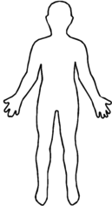 | Organ System 2 =_______________________

2. In biology, structure is related to function. Structure includes:
- the shape of an organ or cell,
- the parts inside the organ or cell, and how these parts are organized.
Give an example of the relationship between function and one aspect of structure for one of the organs in these organ systems.

The organs in the digestive system cooperate to break down food into small molecules that can be absorbed into the blood. Then, the blood carries these molecules to the muscles. The organs
of the digestive system include the:  - mouth where teeth, tongue and jaw muscles work together to begin breaking down food into smaller particles;  - esophagus which carries the mixture of food and saliva to the stomach where acid helps to kill any germs in the food; in addition, the stomach stores a meal and gradually releases small amounts of food for digestion in the small intestine;  - small intestine where enzymes break down food molecules into smaller molecules that can be absorbed into the blood; most digestion and absorption occur in the small intestine, which is narrow but very long;  - pancreas and liver which supply the small intestine with enzymes and other molecules that aid in the digestion of food molecules;  - large intestine where excess water is absorbed into the blood and the feces are stored for excretion. | 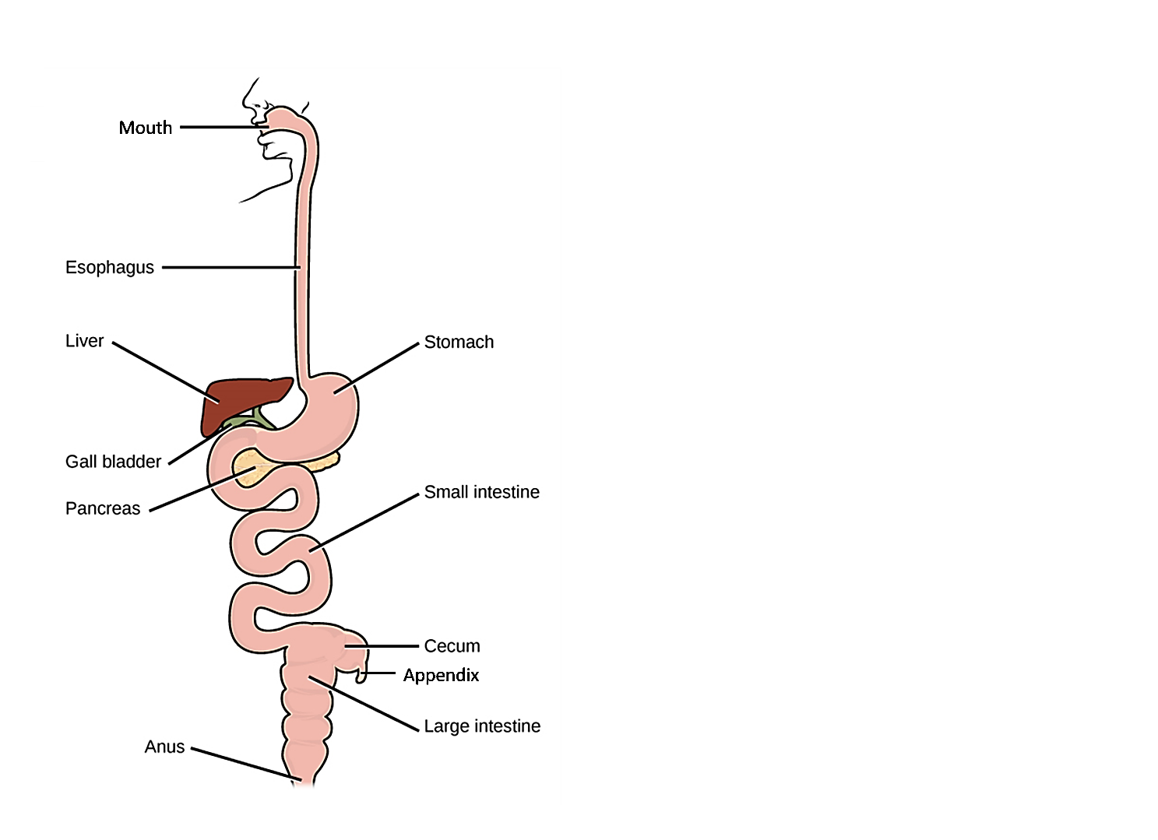

The figure above clearly illustrates the sequence of organs in the digestive system. The figure to the right gives a more realistic picture of the arrangement of these organs in your body.  3a. In your digestive system, efficient function depends on having each organ in the correct sequence from beginning to end. Why is it useful for food to be processed in the mouth before it enters the small intestine? | 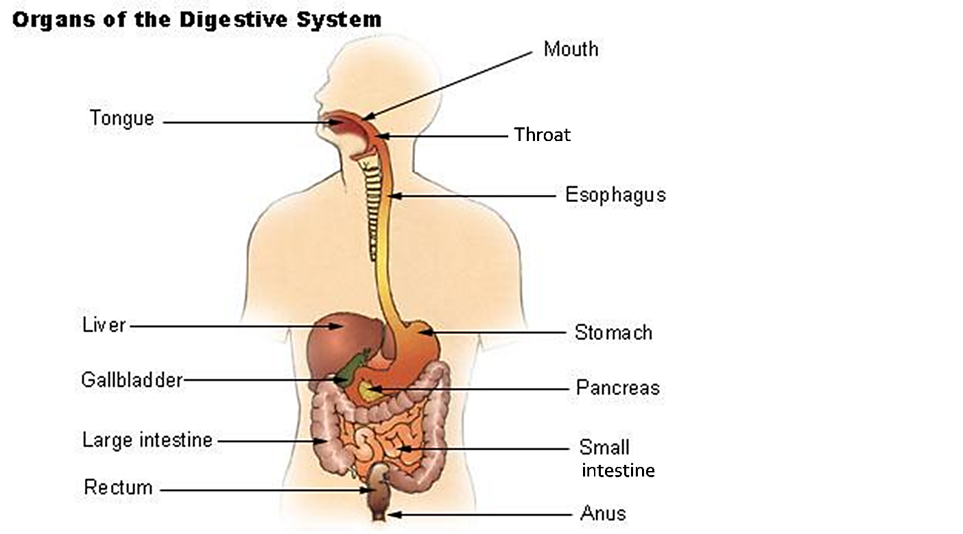

3b. Why is it beneficial to have the stomach before the small intestine?

Notice that an aspect of the structure of the digestive system – how its parts are organized – contributes to its effective functioning.

The small intestine is the location for most of the enzymatic breakdown of food molecules and most of the absorption of digested food molecules into the blood. The space inside the small intestine is called a lumen. The lumen contains a mixture of digestive enzymes and food particles.
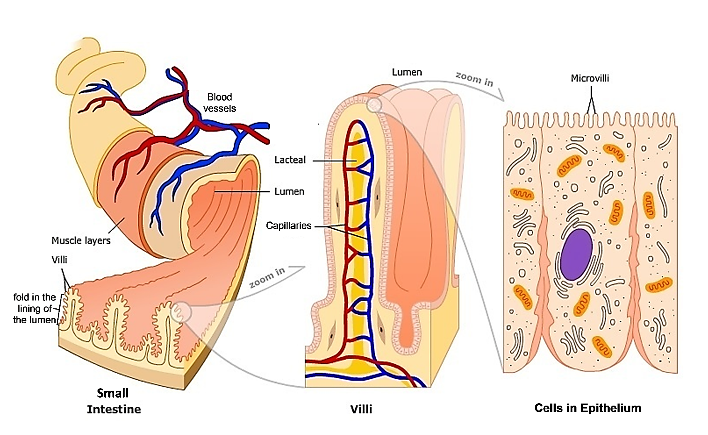

4. The following paragraphs describe how the structure of the small intestine increases both the rate at which enzymes digest food molecules and the rate at which digested food molecules are absorbed into the blood. In the figure, circle each underlined term below; this will allow you to use the figure to help understand the descriptions.
- The muscles in the wall of the small intestine contract repeatedly to mix the digestive enzymes with the food molecules.
- The folds and the many villi in the lining of the lumen contribute to a very large surface area for absorption of digested food molecules. The surface area for absorption is further increased by the microvilli on the surface of each cell lining the lumen of the small intestine.
- Capillaries are the smallest blood vessels. Digested food molecules diffuse across the capillary wall to the blood. The blood carries digested food molecules to muscle cells and other cells throughout the body.

5a. Muscle cells are packed full of proteins that can shorten the muscle cell periodically. How do these proteins contribute to the function of the small intestine?

5b. How do the many villi and microvilli in the lining that surrounds the lumen of the small intestine contribute to the function of the small intestine?

5c. How do the capillaries inside the villi contribute to the function of the small intestine?

As you know, the microvilli on the surface of the cells that line the lumen of the small intestine increase the surface area for absorption of digested food molecules. Another example of how shape is related to function is provided by the thin, flat shape of the cells in the capillary wall.
6. In the small intestine, digested food molecules diffuse into the blood in capillaries. In other parts of the body, digested food molecules diffuse from the blood in capillaries to nearby cells. A capillary wall consists of a single layer of thin, flat cells. Explain why this structure is useful for the function of capillaries. (Hint: Diffusion is relatively rapid over short distances, but very slow over longer distances.) | 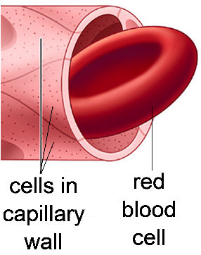

7. The contents of a cell are also related to its function. Match the contents in the top list with the type of cell in the bottom list. (Hint: Proteins that will be secreted from the cell are produced and processed in the rough endoplasmic reticulum.)

lots of proteins that can shorten the cell ___
lots of rough endoplasmic reticulum ___

a. cell in capillary wall
b. cell in pancreas that secretes enzymes for small intestine
c. muscle cell in small intestine
d. red blood cell that carries oxygen from the lungs to the body’s cells
The circulatory system includes the:  - blood, which carries dissolved molecules  - heart, which pumps the blood  - blood vessels (including arteries which carry blood away from the heart, capillaries, and veins which carry blood back to the heart).  8. Explain how the digestive system and circulatory system work together to bring molecules from your food to your muscles. | 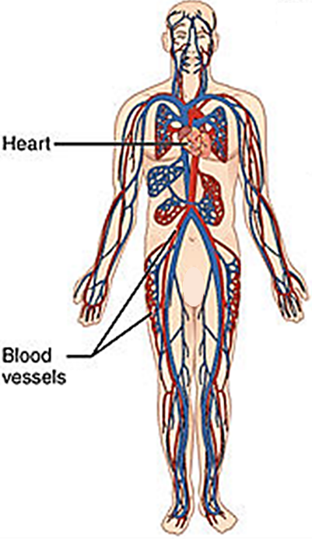
This is an example of the general principle that organ systems cooperate to accomplish a needed function in the body. Another general principle is that a biological structure often contains many repeats of a smaller structure.

9. Give an example of a biological structure and the many repeats of a smaller structure within it.

10. In the table below, summarize evidence to evaluate the claim that “The structure of different types of cells, organs, and organ systems is related to their function.” Structure includes (1) the shape of an organ or cell, (2) the parts inside an organ system, organ or cell, and (3) how these parts are organized.

Examples | Evidence – Description of Structure | Evidence – Description of Function | Reasoning – How the Evidence Supports (or Contradicts) the Claim
Cell – Example 1
= ________

Cell – Example 2
= ________

Organ –
small intestine

Organ System – digestive system

Strengths of the Evidence for the Claim

Limitations of the Evidence for the Claim

By Dr. Ingrid Waldron, Dept Biology, Univ. Pennsylvania, © 2024. This Student Handout and Teacher Notes with instructional suggestions and biology background are available at https://serendipstudio.org/exchange/bioactivities/SFCellOrgan.

