Teacher Notes for “Learning about Genetic Disorders”

This activity provides brief instructions and recommended reliable sources for students to investigate and report on a genetic disorder of their choice.

Learning Goals
In accord with the Next Generation Science Standards:
- This activity helps to prepare students for the following Performance Expectation:
- HS-LS3-1. “Ask questions to clarify relationships about the role of DNA and chromosomes encoding the instructions for characteristic traits passed from parents to offspring.”
- Students will engage in the Scientific Practice:
- Obtaining, Evaluating and Communicating Information. “Gather, read and evaluate scientific and/or technical information from multiple authoritative sources, assessing the evidence and usefulness of each source.”

Instructional Suggestions
As indicated in the Student Handout, we have left it to individual teachers to decide:
- whether students will work on their own or in pairs or small groups;
- the format for student answers to the questions they have chosen;
- whether and how students will share their answers.
One suggested approach would be to have students work individually, in pairs or small groups to find information on their topic. Then, your students would prepare to share their findings, using a whiteboard, poster or PowerPoint. After students share their findings, they can provide feedback to each other, perhaps by a whole-class discussion or a gallery walk (https://www.edutopia.org/blog/enliven-class-discussion-with-gallery-walks-rebecca-alber).

One problem that I have encountered is that some students tend to copy information from their sources without understanding the material well enough to put it in their own words. To avoid this problem, you can encourage your students to follow these guidelines.
1. Use online dictionaries to find the meaning of any unfamiliar technical terms. Reread the original passage until you understand its full meaning.
2. Put the original where you can’t see it, and write the main points you remember in a document in a word processing program or on a note card.
3. Check your version with the original to make sure that your version accurately expresses all the essential information in your own words.
4. Use quotation marks to identify any unique term or phraseology you have borrowed exactly from the source.
5. Record the source (including the page number) in your document or note card so that you can credit it easily if you decide to incorporate the material in your paper.

The recommended sources are indeed reliable. If your students use other sources, you can distribute the next page and ask them to follow the listed procedures to vet each source.

Instructions for Evaluating Sources
(if students use sources other than recommended sources)
Rubric for Evaluating Sources | Additional Points
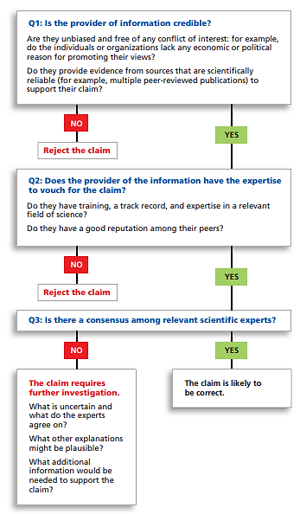 | To find out whether sources may have a conflict of interest, use Wikipedia or fact-checking sources such as Snopes. Do not use “.org” as a sign of reliability. Be cautious about any source that uses emotional language.  Experts in one subject are often unreliable when they write about another subject.  What are the risks of accepting a claim that is ultimately proven to be wrong? What are the risks of not accepting a claim that is ultimately proven to be correct?

By Dr. Ingrid Waldron, Department of Biology, University of Pennsylvania, © 2024. These Teacher Notes and the related Student Handout are available at https://serendipstudio.org/exchange/bioactivities/GeneticsWebSearch.
Quotations from https://www.nextgenscience.org/ and https://www.nextgenscience.org/sites/default/files/HS%20LS%20topics%20combined%206.13.13.pdf.
For this purpose, you will want one whiteboard per student group in your largest class. For information about how to make inexpensive whiteboards and use them in your teaching, see "The $2 interactive whiteboard" and "Resources for whiteboarding" in https://fnoschese.wordpress.com/2010/08/06/the-2-interactive-whiteboard/. To obtain whiteboards, you can go to Home Depot or Lowe's and ask them to cut an 8' x 4' whiteboard (e.g. EUCATILE Hardboard Thrifty White Tile Board) into six pieces with the dimension 32" x 24". They should have a power saw rig that allows their employees to cut the pieces very easily. They should not charge to cut them and the product cost is reasonable. Some important tips for using whiteboards: – Coat the white boards with Endust (or similar product) before using. Every once in a while, wipe them clean and reapply Endust. – Black markers are easiest to erase. To prevent stains, erase right away, especially red or green markers. Do not use markers that are old or almost empty, since the ink from these is more difficult to erase. Recommended brands are Expo markers and Pilot BeGreen markers. To clean up stains you can use Windex or Expo Whiteboard Cleaner. – Teacher and/or students can take a picture of the information on the board if they want to save it. Whiteboards.
The OMIM source is quite technical and will be too advanced for many high school students. This source would be particularly useful if your students want to investigate inherited traits such as albinism or blood type.
This rubric is from https://sciedandmisinfo.stanford.edu/sites/g/files/sbiybj25316/files/media/file/why_trust_science-ecb.pdf.

