Teacher Notes for “Introduction to Global Warming”

To begin this minds-on analysis and discussion activity, students learn about the correlated increases in global temperatures and CO₂ concentrations in the atmosphere. Next, students evaluate an example that illustrates that correlation does not necessarily imply causation. Then, they analyze several types of evidence to test the hypothesis that increased CO₂ in the atmosphere has been a major cause of the increase in global temperatures. This learning activity concludes with a very brief discussion of how global warming has contributed to harmful effects on humans and possible actions to reduce these harmful effects.

Learning Goals
In accord with the Next Generation Science Standards:
      - Students will increase their understanding of Disciplinary Core Ideas:
- ESS2.D: “The foundation for Earth’s global climate system is the electromagnetic radiation from the sun, as well as its reflection, absorption, storage and redistribution among the atmosphere, ocean and land systems, and this energy’s re-radiation into space.” “Changes in the atmosphere due to human activity have increased carbon dioxide concentrations and thus affect climate.”
- ESS3.D: “Human activities, such as the release of greenhouse gases from burning fossil fuels, are major factors in the current rise in Earth’s mean surface temperature (global warming).…”
      - Students will engage in several Science and Engineering Practices.
- Constructing Explanations and Designing Solutions: “Apply scientific ideas, principles and/or evidence to provide an explanation of phenomena and solve design problems, taking into account possible unanticipated effects.”
      - This activity provides the opportunity to discuss the Crosscutting Concepts:
- Cause and effect: Mechanism and explanation. “Students understand that empirical evidence is required to differentiate between cause and correlation and to make claims about specific causes and effects.… They recognize changes in systems may have various causes that may not have equal effects.”
- Stability and Change: “Students understand much of science deals with constructing explanations of how things change and how they remain stable.… They recognize systems can be designed for greater or lesser stability.”
      - This activity helps to prepare students for Performance Expectations:
- HS-ESS2-4: “Use a model to describe how variations in the flow of energy into and out of Earth’s systems result in changes in climate.”
- MS-ESS3-5: “Ask questions to clarify evidence of the factors that have caused the rise in global temperatures over the past century.”

General Instructional Suggestions
To maximize student participation and learning, I suggest that you have your students work individually or in pairs to complete each group of related questions and then have a class discussion after each group of questions. In each discussion, you can probe student thinking and help them develop a sound understanding of the concepts and information covered before moving on to the next group of related questions.

You may want to revise the Word document to prepare a version of the Student Handout that will be more suitable for your students. If you use the Word document, please check the format by viewing the PDF.

A key is available upon request to Ingrid Waldron (iwaldron@upenn.edu). The following paragraphs provide additional instructional suggestions and background information – some for inclusion in your class discussions and some to provide you with relevant background that may be useful for your understanding and/or for responding to student questions.

Additional Information and Instructional Suggestions
The figure on page 1 of the Student Handout presents the anchoring phenomenon – the increase in global average temperature beginning in the early twentieth century. The driving question for the activity is “What caused this increase in global average temperature?”

Changes in global temperature are estimated relative to the 1850-1900 average, as explained in this quote:
“In the late 1970’s, Hansen turned his attention to similar calculations of the effects of Earth’s atmosphere on its surface temperature. As part of this work, he tackled the problem of creating a standardized method for calculating global average temperature trends. The method begins with the recognition that, while absolute temperatures are widely variable from place to place on the Earth, even for locations relatively close to one another, temperature changes of nearby locations tend to be very similar. For example, while the absolute temperatures in New York and Pittsburgh might be quite different on a particular day, if one is having a hotter than average month, the other is likely having a month hotter than average by around the same amount. Thus, global temperature trends are plotted, not as absolute temperatures, but as temperature differences, called “temperature anomalies,” relative to some reference temperature.”
(http://www.rescuethatfrog.com/history-of-evidence/)

During your discussion of student answers to question 1, you will probably want to introduce the distinction between climate and weather. Climate is the average weather over long time periods and the typical pattern of variation of weather statistics, including temperature, precipitation, wind, cloudiness, etc. Climate is more long-term, whereas weather is more short-term and subject to considerable variation from day-to-day and year-to-year.

The figures below show data to support the assertions that CO₂ concentration in the atmosphere has increased during the last century and current levels of CO₂ in the atmosphere are higher than at any time in the past 800,000 years. Evidence that burning fossil fuels has been the main cause of the increase in CO₂ levels is summarized in https://skepticalscience.com/co2-increase-is-natural-not-human-caused.htm.

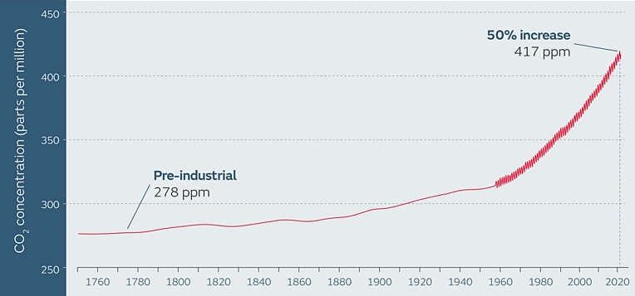
(https://www.carbonbrief.org/met-office-atmospheric-co2-now-hitting-50-higher-than-pre-industrial-levels/)

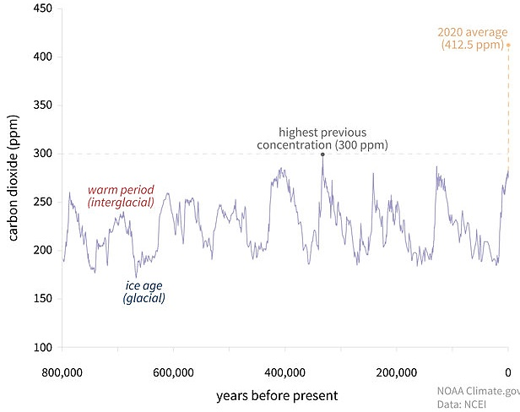
(https://www.climate.gov/news-features/understanding-climate/climate-change-atmospheric-carbon-dioxide)

Question 3 states that men’s height increased during the twentieth century. The figure below shows supporting data. (The height data are for men only, because early data from military recruits allows a much longer time series for men than for women.)

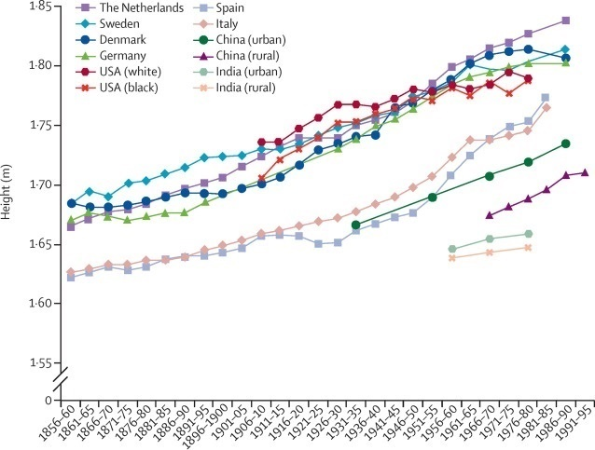
Adult
Birth cohort (dates of birth)

(http://www.thelancet.com/cms/attachment/2060860246/2062777442/gr1.jpg)

I assume that students will recognize that there is no plausible way that increases in men’s height could cause global warming. The flowchart below shows one way that variables can have correlated trends even when neither variable is causing the other.
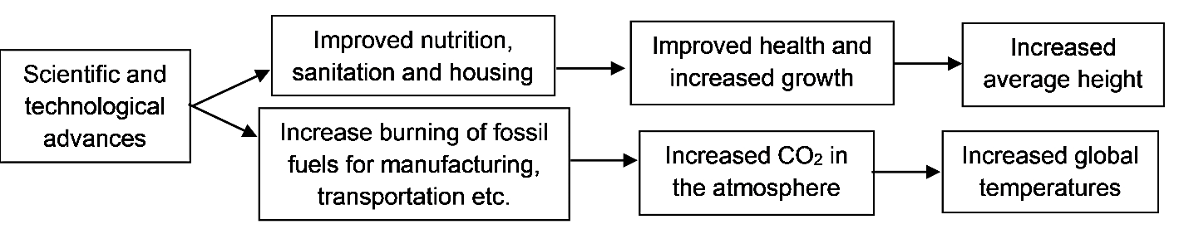

After question 3 introduces students to the concept that correlation does not necessarily imply that one variable causes the other variable, then students evaluate the causal hypothesis that the increase in atmospheric CO₂ has been a major cause of the increase in global temperatures. Specifically, in questions 4-6, students analyze the results from research in which scientists:
- investigated the mechanism that can explain how more CO₂ in the atmosphere could cause global warming
- tested the ability of the hypothesis to predict future trends
- evaluated whether other hypotheses could account for the observed trends.
You may want to point out to your students that each type of evidence could provide the opportunity to falsify the causal hypothesis (e.g. if the hypothesis failed to predict future trends). This analysis provides the opportunity to discuss the Cause and Effect Crosscutting Concept: “Students understand that empirical evidence is required to differentiate between cause and correlation and to make claims about specific causes and effects.”

The Student Handout (page 2) describes the basic mechanism by which CO₂ in the atmosphere warms the earth. The earth absorbs sunlight and emits infrared radiation. Molecules of CO₂ absorb some of this infrared radiation and emit infrared photons in any direction. Thus, some of the infrared radiation goes back to earth and less of the infrared radiation goes out to space. Other greenhouse gases (e.g., methane (CH₄) and nitrous oxide (N₂O)) contribute to global warming by the same mechanism (see the figure below). Additional evidence for this mechanism comes from the good match between:
(1) the wavelengths of heat energy absorbed and emitted by CO₂ and other greenhouse gases in laboratory experiments and
(2) the wavelengths of the heat energy that is radiated back to earth and prevented from escaping to space.
Additional information and explanations are available at https://www.ldeo.columbia.edu/news-events/how-exactly-does-carbon-dioxide-cause-global-warming.

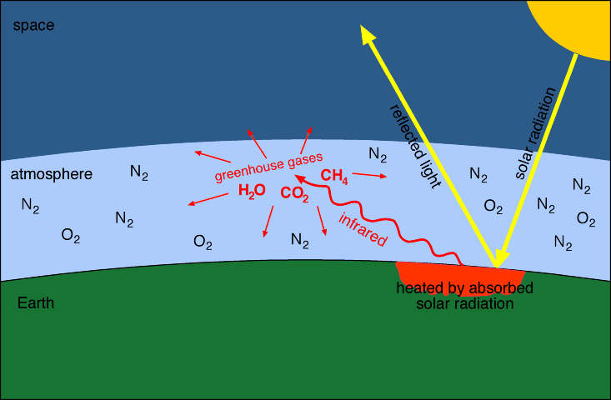
(Greenhouse gases include CO₂, CH₄, H₂O and N₂O (not shown), but not N₂ or O₂. https://kiranvoid.files.wordpress.com/2014/04/greenhouse.gif)

It should be mentioned that actual greenhouses work mainly by another mechanism. In a greenhouse, locally warmed air is trapped by the walls and ceiling of the greenhouse. Thus, a greenhouse reduces heat loss due to both convection and radiation, whereas greenhouse gases reduce heat loss due to radiation.

An analysis published in 2019 concluded “that climate models published over the past five decades were generally quite accurate in predicting global warming in the years after publication, particularly when accounting for differences between modeled and actual changes in atmospheric CO₂ and other climate drivers. This research… increases our confidence that models are accurately projecting global warming.” (https://agupubs.onlinelibrary.wiley.com/doi/full/10.1029/2019GL085378) Nevertheless, there is still uncertainty about future trends, due to hard-to-predict complex feedback effects and uncertainty about future human behavior.

The animated graph referred to in question 5 provides an engaging way of presenting the contributions of different factors that influence global temperature. (These causal factors are sometimes referred to as forcings.) If your students have access to the Internet, you may want to check whether they will be able to access this specific website through your school Internet service. If your students do not have Internet access, you can show them the animation or incorporate the figure below in the Student Handout. This figure provides similar information to the animation. If you use this figure, you will need to revise the table in question 5. In this figure, natural variability refers to the El Niño/Southern oscillation. The anthropogenic component includes a warming component from greenhouse gas concentrations and a cooling component from anthropogenic aerosols.

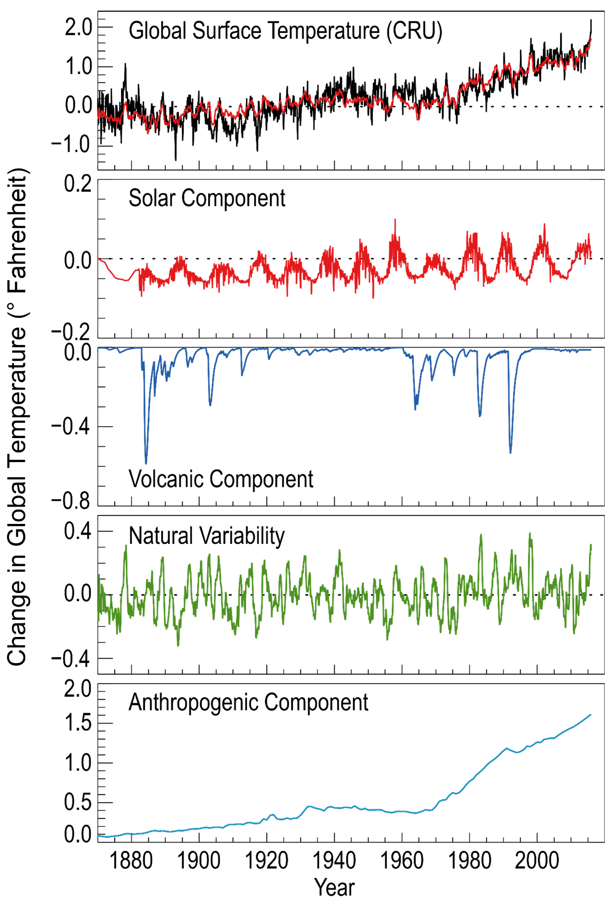(https://science2017.globalchange.gov/chapter/3/)
See pages 4-6 of these Teacher Notes for points to include in your class discussion of student answers to question 6. Additional evidence for the causal hypothesis that increased greenhouse gases have been the primary cause of global warming is reviewed in https://www.skepticalscience.com/empirical-evidence-for-co2-enhanced-greenhouse-effect.htm.

It seems obvious that global warming will result in more frequent and intense heat waves. What may be less obvious is how many deaths can result from heat waves, particularly among the elderly, outdoor workers and poor people who don’t have access to air conditioning (https://interactive.carbonbrief.org/attribution-studies/index.html; https://science.nasa.gov/earth/climate-change/extreme-makeover-human-activities-are-making-some-extreme-events-more-frequent-or-intense/).

Increased temperatures have resulted in changed precipitation in many parts of the US (see flowchart and figure below).

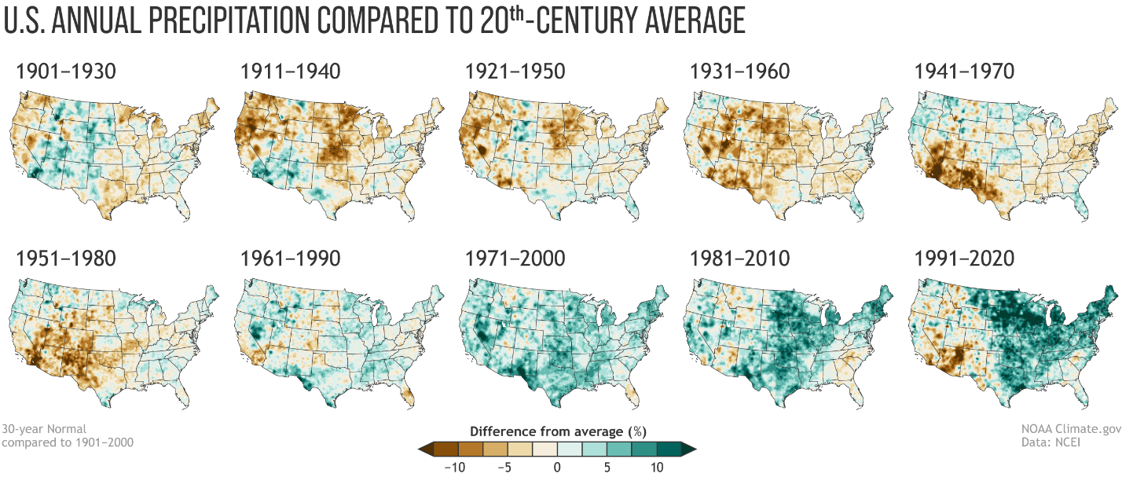(https://www.noaa.gov/sites/default/files/legacy/image/2021/Apr/30yrNormal_Precip_1901-2000_2480.png)

The increased frequency of heavy rainfall events has resulted in increased flooding of rivers and streams in the Northeast and Midwest of the US. In contrast, increased temperatures have caused changes in wind patterns that have resulted in decreased rainfall in the southwestern US, resulting in drought and increased forest fires (https://www.epa.gov/climate-indicators; https://www.nytimes.com/interactive/2021/05/12/climate/climate-change-weather-noaa.html).

For more information on the observed and predicted effects of global warming, see:
- https://science.nasa.gov/climate-change/effects/ for the US
- https://www.ipcc.ch/report/ar6/wg1/#SPM and https://www.ipcc.ch/report/sixth-assessment-report-working-group-ii/ for a global perspective

The figure below shows projections of future temperatures under conditions listed on the right. If we reach 1.5°C warming relative to preindustrial times, this amount of warming may well cause irreversible changes that would have positive feedback effects to accelerate global warming (e.g. melting permafrost releasing the greenhouse gas, methane (CH₄), and Arctic sea ice melting, which results in less reflection of sunlight and more absorption of sunlight and thus more heating) (https://www.nature.com/articles/d41586-019-03595-0).

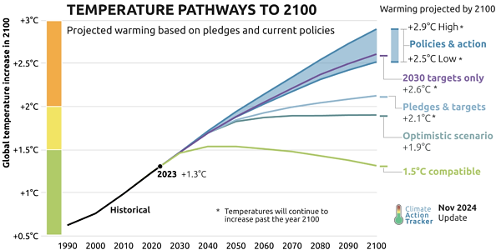
(https://climateanalytics.org/publications/cat-global-update-as-the-climate-crisis-worsens-the-warming-outlook-stagnates)
To learn what effects can be anticipated, you can have your students view either of the videos listed below.
- What Earth in 2050 Could Look Like (~5 minutes; https://www.youtube.com/watch?v=2njn71TqkjA)
- What does three degrees of warming look like? (~16 minutes; https://www.youtube.com/watch?v=uynhvHZUOOo)

In discussing student answers to question 7, you will probably want to welcome all reasonable student answers. In addition, you may want to mention the findings of a study that “recommends four widely applicable high-impact (i.e. low emissions) actions with the potential to contribute to systemic change and substantially reduce annual personal emissions:
- having one fewer child (average for developed countries of 58.6 tons CO₂ equivalent (tCO₂e) emission reductions per year)
- living car free (2.4 tCO₂e saved per year)
- avoiding airplane travel (1.6 tCO₂e saved per round-trip transatlantic flight)
- eating a plant-based diet (0.8 tCO₂e saved per year).
(Source = https://iopscience.iop.org/article/10.1088/1748-9326/aa7541)
This research article presents evidence that adoption of these actions (especially by teenagers and young adults) would make a much greater long-term contribution to reducing greenhouse gas emissions than some frequently recommended personal actions such as recycling, upgrading light bulbs, hanging laundry out to dry, and washing clothes in cold water. Additional effective personal actions include purchasing green energy for the home and buying a more fuel-efficient car. (Additional information on this study is available at https://iopscience.iop.org/article/10.1088/1748-9326/aa7541 and https://www.sierraclub.org/sierra/we-re-teaching-kids-wrong-ways-fight-climate-change.)

It should be mentioned that, to avoid the worst effects of climate change, individual actions must be supplemented by governmental policies, so voting for politicians who recognize the importance of limiting global warming is another important personal action to take.

If your students would like to calculate their carbon footprint for travel, home, shopping and food, they can use the footprint calculator available at https://ecological-footprint-calculator.climatehero.org/ or https://www.footprintcalculator.org/en/results/0/facts-figures. They will probably need to check with an adult in their household to get some of the information needed to complete the carbon footprint calculation.

Related Activities
This activity was designed as an introduction to “Food and Climate Change – How can we feed the growing world population without increasing global warming?”
(https://serendipstudio.org/exchange/bioactivities/FoodClimateChange).
In this analysis and discussion activity, students learn how food production contributes to the release of three greenhouse gases – carbon dioxide (CO₂), methane (CH₄), and nitrous oxide (N₂O). Students use biological concepts (e.g. trophic pyramids) to interpret data concerning the very different amounts of greenhouse gases released during the production of specific types of food. Finally, students propose, research, and evaluate strategies to reduce the amount of greenhouse gases that will be released during future production of food for the world’s growing population.

If you want to supplement this brief introduction to greenhouse gases, global warming and climate change, you may want to use one of the recommended curricula listed on page 1 of “Resources for Teaching about Climate Change” (https://serendipstudio.org/exchange/bioactivities/ClimateChange). This annotated list includes resources that can help your students develop more in-depth understanding of the causes and consequences of global warming and climate change. Also included are resources to introduce students to proposals to reduce the amount of global warming and reduce the harmful effects of climate change.

Sources for Student Handout Figures
- figure on page 1 – modified from https://berkeleyearth.org/global-temperature-report-for-2025/
- figure on page 2 – modified from figure previously available at https://www.ucapture.com/wp-content/uploads/2016/07/Global-Warming-Infographic.png

By Dr. Ingrid Waldron, Department of Biology, Univ. Pennsylvania, © 2026. These Teacher Notes and the Student Handout for this activity are available at https://serendipstudio.org/exchange/bioactivities/IntroGlobalWarming.
https://www.nextgenscience.org/
Agriculture is an important source of N₂O and CH₄ (see our follow-up learning activity, “Food and Climate Change – How can we feed a growing world population without increasing global warming? https://serendipstudio.org/exchange/bioactivities/FoodClimateChange).
This animated graph is also available at https://www.youtube.com/watch?v=-gHUHoqBn-Y and https://www.facebook.com/watch/?v=10154477836368076.
In addition, coastal flooding has also increased due to an increase in global sea level has risen by about 9 inches since 1880 (https://www.epa.gov/climate-indicators/climate-change-indicators-sea-level). Rising sea levels have been caused by increased melting of glaciers and the expansion of ocean water as the oceans have warmed. Scientists expect global sea level to rise by 0.3-1.0 m by 2100 (https://www.ipcc.ch/report/ar6/wg1/). This would probably result in substantial flooding in many coastal cities in the US (e.g. Miami, New York City) and around the world (https://science2017.globalchange.gov/chapter/12/). The risk of coastal flooding has been exacerbated by the increased intensity of hurricanes (https://www.pnas.org/doi/10.1073/pnas.1920849117).
Increased education of girls and women and increased availability of family-planning can reduce population growth which could make a significant contribution to fighting global warming (https://populationmatters.org/climate-change).
The recommended follow-up activity, “Food and Climate Change – How can we feed the growing world population without increasing global warming?”, explains how eating meat contributes to global warming and why eating a plant-based diet is an important way to help reduce global warming.

