Understanding and Predicting Changes in Population Size
– Exponential and Logistic Mathematical Models vs. Complex Reality

In biology, a population is a group of individuals of the same species that live in the same area at the same time. An example of a population is a flock of whooping cranes that live in a wetland in Texas during the winter and migrate to a wetland in Canada for the summer.

Recovery of Endangered Species – Why does it take so long?

An endangered species is a type of animal or plant that is at risk of becoming extinct because of low numbers and environmental threats. For example, the number of wild whooping cranes decreased from 10,000 or more before European settlement to about 20 in the 1940s. This drastic decrease was caused by hunting with guns and loss of wetlands as they were converted to farms and towns.  After the 1940s, conservation efforts included laws against killing whooping cranes and protection of the wetlands where whooping cranes were living. As a result, the surviving population of wild whooping cranes increased from about 20 in the 1940s to more than 500 in 2025. Some data for this | 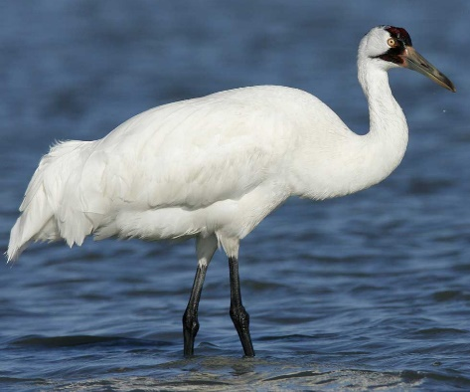  How tall do you think a whooping  crane is? To learn more and see whooping cranes in action, go to  this link or this link.
population are shown in the graph and table below.

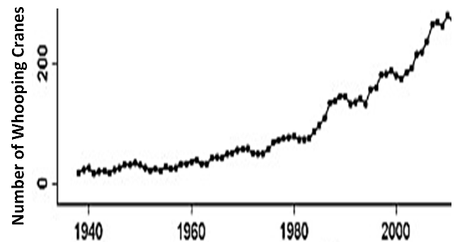
  Dates | Average number  of  whooping cranes | Increase during the previous  20 years
  1950-1955 | 24.4
  1970-1975 | 53.0 | 28.6
  1990-1995 | 138.0 | 72.0
  2010-2015 | 290.6 | 152.6

1a. For this population of whooping cranes, did population size increase by the same amount during each 20-year period from 1950 to 2015? yes___ no ___

1b. On average, when was the increase in population size bigger?
in earlier decades ___ in more recent decades ___

2. What are possible reasons why the increases in population size have been bigger in more recent decades?

We will return to an analysis of the recovery of endangered species, but first you will learn more about population growth by analyzing simpler examples.

Exponential Population Growth
A single bacterium is put in a container with plenty of food. After 30 minutes the bacterium divides into two bacteria. Then, every 30 minutes, each bacterium in the container divides in two. As a result, population size doubles every 30 minutes.  3. Add to this figure to show how population size will double  from 60 minutes to 90 minutes. | 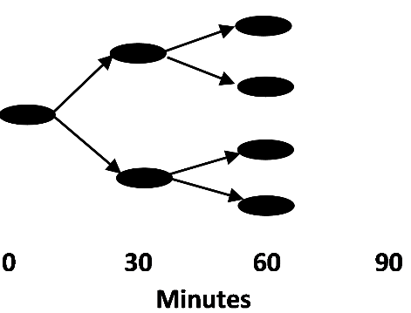

4. Complete this table to show how many bacteria there will be at each time if the number of bacteria doubles every 30 minutes. Then, fill in the “Increase in # bacteria” blanks.

Time (minutes) | 0 | 30 | 60 | 90 | 120 | 150 | 180 | 210 | 240 | 270 | 300
# Bacteria | 1 | 2

Increase in # bacteria ___ ___ ___ ___ ___ ___ ___ ___ ____ _____

Notice that, for each 30-minute interval, ΔN = N, where
    - ΔN (pronounced delta N) represents the change in the number of bacteria from the beginning to the end of a 30-minute interval
    - N represents the number of bacteria at the beginning of the 30-minute interval

5. Explain the biological reason why ΔN = N for each 30-minute interval.

6a. Graph the number of bacteria at each time. Connect the points to show the population growth curve.  6b. Why did population size increase slowly at the beginning and more rapidly at later times?  Exponential population growth occurs when the rate of population growth increases as population size increases (ΔN is proportional to N). This bacterial population showed exponential population growth. | 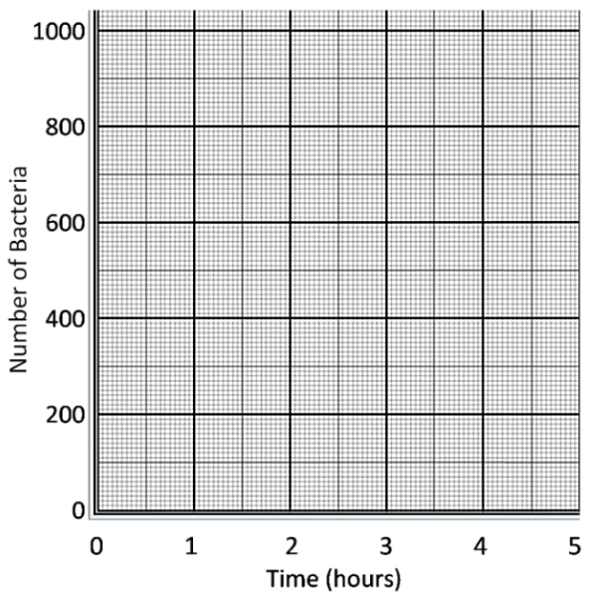

7. What evidence supports the conclusion that the whooping crane population also showed roughly exponential population growth? (Hint: See the table on the previous page.)

8a. Can exponential growth of this bacterial population continue forever? yes ___ no ___

8b. Why or why not?
Limits on Population Growth

This graph shows trends in population size for a population of bacteria that grew on a piece of tofu. During the first twenty hours, population size increased from a few hundred bacteria to about ten million bacteria. After that, population growth slowed and then stopped.  9. What is a possible reason why this population of bacteria stopped growing? | 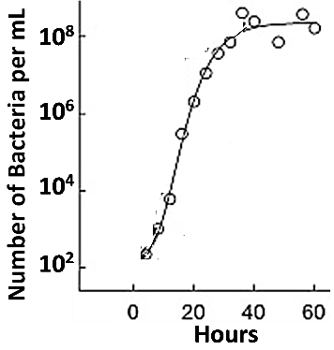

Paramecia are single-cell organisms that live in water and eat bacteria. This graph shows the results of an experiment with Paramecia.  Two populations of Paramecia grew in two tubes. These tubes had the same volume of water. However, the tube where | 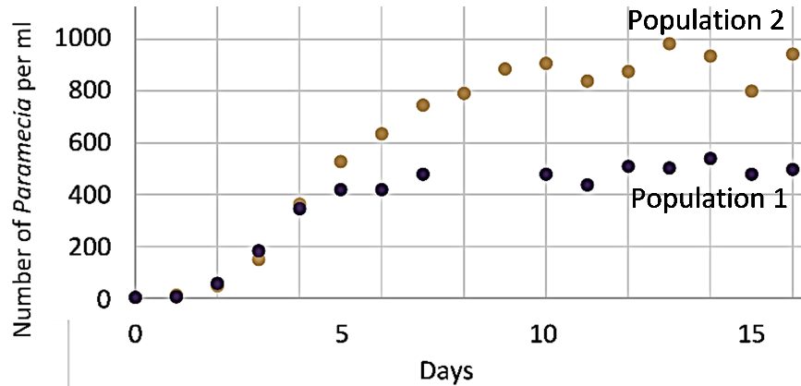
Population 2 grew had twice as much food for Paramecia as the tube where Population 1 grew.

10a. What was the main limiting factor that determined how many Paramecia could live in the tubes? the amount of food ___ the amount of space ___

10b. What evidence supports your answer?

11. As population size increases, competition for limited resources __________________. An
(decreases/increases)
increase in competition results in increased mortality and/or decreased reproduction, so

population growth slows and stops. As a result, population size reaches a _______________,
(maximum/minimum)
which is called the carrying capacity of the environment. This type of population growth is called logistic population growth. In contrast, exponential population growth occurs when

resources are so ______________ that there is little or no competition for resources.
(abundant/scarce)

12a. This figure shows the growth of two populations of the same kind of animal, living in two different environments. The amount of resources in the environment was  - much bigger for population A.  - much bigger for population B.  - about the same for both populations.  12b. Population ___ shows exponential population growth.  Population ___ shows logistic population growth. | 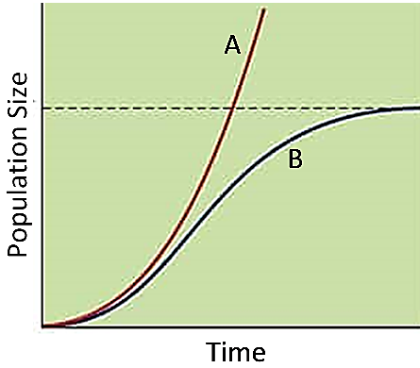  The dashed line shows the carrying capacity of the environment for population B.
This table compares the mathematical equations for exponential vs. logistic population growth for bacteria.
Exponential Population Growth | Logistic Population Growth
ΔN = N  where  - ΔN is the change in the number of individuals from the beginning to the end of a time interval  - N is the number of individuals at the beginning of the time interval | (K – N)  ΔN = N x ---------  K  where  - ΔN and N are the same as for exponential growth  - K is the carrying capacity of the environment = the number of individuals that can live in the environment

13a. Notice that the first part of the equation for logistic population growth is the same as the equation for exponential population growth. Circle the algebraic expression that has been added in the logistic population growth equation.

13b. Fill in each blank in the paragraph below with the appropriate algebraic expression:
K or K - N or (K - N)/K

When there are N individuals in the population, the number of additional individuals that can live in the environment is ________. Therefore, the fraction of carrying capacity that is still available for population growth is _________.

14a. Calculate (K - N)/K for K = 100 and N = 1.
14b. Calculate (K - N)/K for K = 100 and N = 99.
14c. Complete the following table.

 | Provide an explanation based on the equations for exponential and logistic population growth. | Provide a biological explanation.
Explain why logistic population growth is similar to exponential population growth when N is small.
Explain why logistic population growth slows to nearly 0 as N gets close to K (i.e., as N gets close to the carrying capacity).

15. The equations (at the top of this page) and the figure (in question 11) are two different versions of the exponential and logistic population growth models. Give one advantage of each version of these models.

Advantage of the figure:

Advantage of the equations:
Using the Exponential and Logistic Population Growth Models
to Understand Recovery of Endangered Species

A model is a simplified representation of reality that can help us to understand a real-world phenomenon. For example, the exponential and logistic population growth models help us to understand and predict changes in population size for endangered species.
In 1975, Jim predicted the future growth in the number of whooping cranes in Texas. He knew that this number had increased from about 24 in 1955 to about 53 in 1975.  Since population size had increased by about 30 in the past twenty years, Jim predicted that population size would increase by about 30 every twenty years in the future. Thus, Jim predicted that, by 2015 | 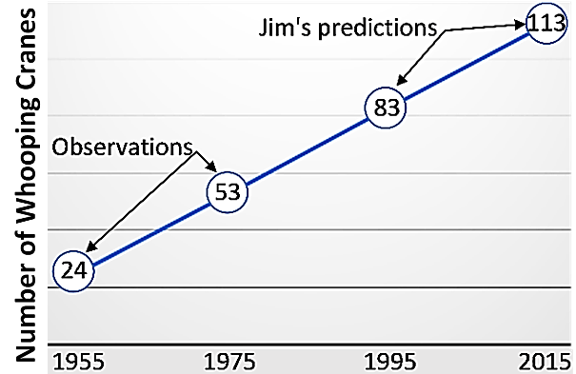
(forty years after 1975), population size would reach approximately 53 + 30 + 30 = 113 whooping cranes. We now know that the actual population size in 2010-2015 was about 290, more than double Jim’s prediction.

16. What was wrong with Jim’s reasoning? Why was his prediction so much lower than actual population growth?

Conservation biologists have used two approaches to prevent the extinction of whooping cranes. First, they helped the one surviving population of wild whooping cranes to increase in size. Second, they tried to establish additional populations of whooping cranes in other locations. To achieve this second goal, they carefully trained the offspring of captive whooping cranes to survive in the wild and introduced them to new locations.

17a. Conservation biologists expected that, eventually, the total number of wild whooping cranes would be greater if there were several populations in different wetlands, instead of a single population in one wetland. Explain why. (Hint: Think about carrying capacity.)

17b. What is another reason why there is less risk of extinction if there are several populations of whooping cranes at different locations and not just one population in a single location?

The Endangered Species Act (ESA) was passed in 1973 to prevent the extinction of endangered species in the US. Critics of the ESA argue that the ESA has been ineffective since, so far, only about 3% of all species covered by the ESA have recovered enough that they are no longer considered endangered. In contrast, supporters of the ESA argue that only about 1% of species covered by the ESA have gone extinct. Also, population growth is expected to take a long time, especially when recovery efforts start from a very small population and the endangered species has a low birth rate.

Conservation biologists are also concerned about the many species that are not yet endangered, but have decreasing total number of individuals. These decreases have been due to loss of the habitat that the species need and other hazards caused by people. If these trends continue, some of these species will probably become endangered.
18. Suppose that you had to choose between conservation efforts that focus on endangered species vs. conservation efforts that focus on species that are not yet endangered, but have decreasing numbers. To help you decide which approach to take, complete this table.

Focus of Conservation Efforts | A Major Advantage of this Focus | A Major Disadvantage of this Focus
Endangered species
Species that are not yet endangered, but have decreasing numbers

Exponential and Logistic Population Growth Models vs. Complex Reality
The exponential and logistic population growth models can explain some trends in population size, but not others. For example, page 1 describes two major trends in numbers of whooping cranes.
- Before about 1950, the total number of whooping cranes decreased drastically and many populations of whooping cranes were entirely eliminated by hunting and habitat loss.
- After about 1950, the surviving population of whooping cranes increased in size, slowly at first and then more rapidly.

19a. Which of these trends could be predicted or explained by the exponential population growth model? A ___ B ___

19b. Does either the exponential or logistic population growth model ever predict a decrease in population size? yes ___ no ___

Notice that neither the exponential nor the logistic population growth model includes the effects of changes in the environment, such as increased hunting or habitat loss. Therefore, neither model can predict or explain the decrease in whooping crane populations before 1950.

Human hunting has decreased population size for many species. This can have indirect effects on population size for other organisms in the same ecosystem. For example, hunting drastically reduced the populations of sea otters, so sea otters were rare at the beginning of the twentieth century. This affected population size for the other organisms in this food chain.

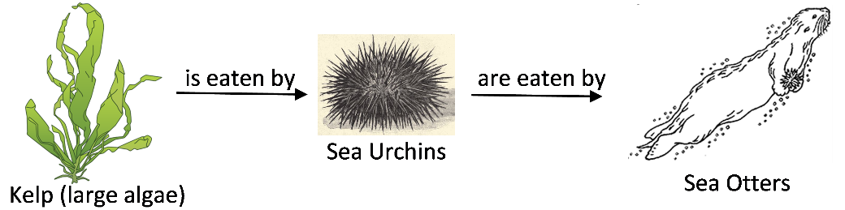

20a. Predict the effect of a decrease in sea otter population size on sea urchin population size. Explain your reasoning.

20b. Predict the effect of a decrease in sea otter population size on the abundance of kelp. Explain your reasoning.

21. To summarize what you have learned thus far, fill in one match per blank. (You may use each match more than once.)
The exponential population growth model includes ____
The logistic population growth model includes ____ ____
In the real world, population size can be affected by ____ ____ ____

- increases in population size as a result of reproduction
- the effects of changes in the environment
- the effects of competition for limited resources

Models can help us understand and predict biological phenomena such as changes in population size. However, all models are based on simplifying assumptions. For example, the logistic population growth model assumes that:
- carrying capacity is constant (e.g. no habitat destruction);
- as population size approaches the long-term carrying capacity, population growth slows promptly, so the population size does not exceed the long-term carrying capacity.

This graph illustrates what can happen when these simplifying assumptions are not true. In 1911, 25 reindeer were brought to an island off the coast of Alaska. Initially, food was plentiful, and the number of reindeer increased. By the late 1930s the large population of reindeer had drastically reduced the amount of lichen (which the reindeer depended on for their winter food). The reindeer population size fell in the 1940s. However, the slow-growing lichen had not recovered by 1950. | 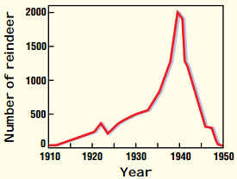

22a. Scientists believe that originally the carrying capacity of the island was about 700 reindeer. Draw the expected trend in population size if population growth followed the logistic population growth model with a carrying capacity of 700 reindeer; start from the actual population size in the early 1930s.

22b. By 1950, the number of reindeer had fallen well below the original carrying capacity of 700. Explain why population size fell so low.

22c. Why didn’t the logistic population growth model accurately predict the trends in the size of this reindeer population?

22d. Suppose the researchers had stopped collecting data after 20 years, in 1931. What would they have concluded about growth of this reindeer population? What would they have missed?

This graph shows seasonal changes in population size for a population of rabbits that lived in the northern US.

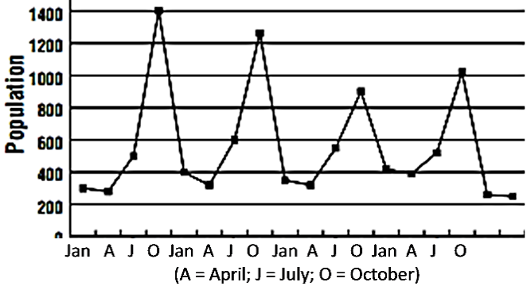

23a. How did population size change from October to January each year?

23b. What is one possible cause of the decrease in population size between October and January? Do you think that carrying capacity for rabbits was constant throughout the year?

23c. Suppose the researchers had only measured population size once a year at the same time each year. What important effect would the researchers have missed?

24a. Dr. Smart declared, “The exponential and logistic population growth models are useless. I have developed a new model that can accurately predict changes in population size for any population anywhere.” Biologists disagree with both sentences in this quotation. Give examples that illustrate how the exponential and logistic population growth models are useful.

24b. Explain why we should not believe Dr. Smart’s boast that his model will be accurate for all populations.

Human Population Growth

Biologists define a population as a group of individuals of the same species that live in the same area at the same time. In contrast, in this section, we will discuss changes in the total number of people on the Earth (see figure).

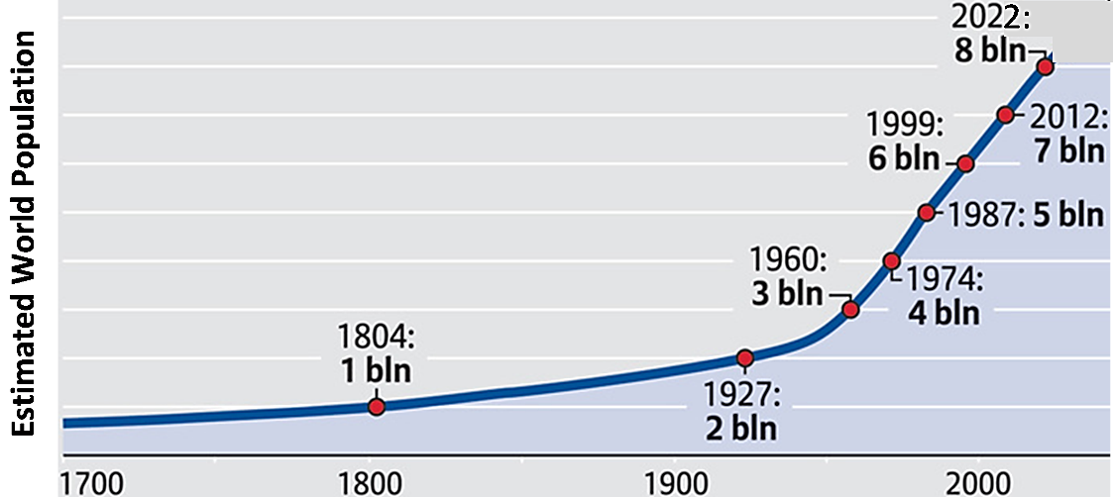

25. It took many thousands of years for world population to reach 1 billion people. Then, it took a little over a century for world population to add 1 billion more people. After that, world population increased by 6 billion in less than a century. Explain how the exponential population growth model helps us to understand these trends in world population growth.

26. Can you conclude from the above graph that the Earth’s long-term carrying capacity is at least 8 billion people? Explain your reasoning. (Hint: Remember the reindeer.)

What is the Earth’s carrying capacity for people? In other words, how many people can the Earth support in the long-term? Scientists disagree about the answer to this question, but all agree that the Earth’s carrying capacity will be influenced by people’s behavior. For example, the Earth’s carrying capacity is influenced by the amount and type of food that people consume.

27. The average person in the US consumes approximately 30% more calories and almost three times as much meat as the average person in the world. Suppose that the average consumption per person in other parts of the world increased to equal the US average. How would this change the Earth’s carrying capacity for people? Explain your reasoning.

By Dr. Ingrid Waldron, Biology Department, University of Pennsylvania, © 2025. This Student Handout, a shorter version without equations, and Teacher Notes (with instructional suggestions and background biology) are available at https://serendipstudio.org/exchange/bioactivities/pop. The recommended links under the picture of the whooping crane are the first 7 minutes of https://www.youtube.com/watch?v=ACUYXCLTvm8 and https://journeynorth.org/t m/crane/jr/JnKidsOverview.html.

