**Beyond Smartness:**

**Disrupting the Hegemony of Smartness Through Disability Studies**

By Emily Kingsley

*Discovering my project topic at an intersection of interests-*

I had originally planned to center my project around accessibility in the classroom. However, as I began getting deeper into my work, I realized that this did not quite feel right; there was something more for me to study that I just hadn’t quite grasped yet. Then I found Zeus Leonardo and Alicia Broderick’s 2011 article, “Smartness as Property: A Critical Exploration of Intersections Between Whiteness and Disability Studies.” I was blown away—this piece represented the perfect intersection of my academic interests in race, disability, and education. In reading the article, I felt like I was discovering a new field of study that I had never known existed, and I was excited. This project, then, represents my first exploration into the joint intellectual trajectory of critical whiteness and critical disability studies. It is only a first (somewhat tentative) step into intersectional scholarship and critical pedagogy—subjects that I hope to explore further as I continue my academic career.

*A note about positionality and privilege-*

As I engage with this complex and contentious subject, it is important for me to name the lenses and biases that I bring to this work. I identify as a white, neurotypical female, and these markers position me in a very particular way in relation to the topic I am talking about here. For one thing, it represents an incredible amount of privilege for me to be able to theorize about smartness and the implications of smartness for people with intellectual abilities when I know that it is not my own smartness, my own intelligibility that is on the line. As a neurotypical individual, my ability to deal fully with this subject is inevitably limited. Indeed, the opinions, stories, and lived experienced of people with intellectual disabilities must be brought into the picture if this discussion is to be a truly authentic and radical one.

March 7, 2016

**“The figured world of smartness is located within us, not as a biological capacity but, instead, as a cultural practice we use to invest meaning in others and ourselves” –Beth Hatt, “Smartness as a Cultural Practice in Schools,” p. 457**

**I am smart. I am. I am. Right?**

For me, smartness is a full-time job. It is a constant pressing, pushing desire to count, to be counted. To be intelligent. Gifted. High-achieving. Intellectual. Talented. Worthy. Every day, I am on the clock— working constantly to perform my smartness, to look smart, talk smart, act smart, be smart. But the real kicker? I am never

Quite

Smart

Enough.

Throughout my education career, the smartness label has been a constant companion. From as early as kindergarten, I remember feeling proud of my intellectual abilities—feeling warmed by a notion of my own smartness that was reinforced by teachers, parents, and peers. I knew I was smart, and my good grades and academic achievement proved it. Yet, this relationship—between my smartness and me—became an incredibly contentious one. As SAT scores, transcripts, and college acceptances/rejections took on increasing significance, my belief in my own intelligence became more and more tenuous. This is still true today. I am painfully aware of how precarious my smartness is—that one embarrassing comment in class, one bad grade, one moment of “laziness” (the ultimate sin) could bring it all toppling down.

This is a high-stakes matter. Smartness is so tightly wrapped up in my identity and sense of self-worth that it would take years of chopping away at its tightly-gripping tendrils to loosen its hold on me. Even at a place like Haverford, where grades are not discussed openly and collaboration is valued over competition, I have not been able to outrun the specter of smartness. It clings to my everyday interactions and exchanges and sends a barrage of thoughts clanging through my head: Does _____ think I am smart? Is ______ smarter than me?

So much of my smartness rhetoric is rooted in comparison, in a constant questioning of how I compare to those around me.

And that is where The Question comes in.

It is a question that upset and unsettled me. One that I didn’t think I should be asking but also couldn’t seem to avoid.

Are people with intellectual disabilities smart?

The question threw me off balance. I spend so much time theorizing about my own intelligence and that of others, yet I didn’t know how to fit people with intellectual disabilities into my finely-honed framework. I could not find a way to conceptualize how the neurodivergent mind might operate within the strict parameters of ‘smart’ that I had grown accustomed to. Turning to mainstream internet sources seemed to confirm this incompatibility of smartness and intellectual disability.

healthychildren.org—a site sponsored by the American Academy of Pediatrics—offers the following perspective:

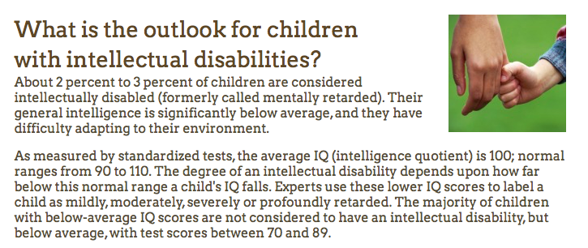

The DSM-V provides its take as well:

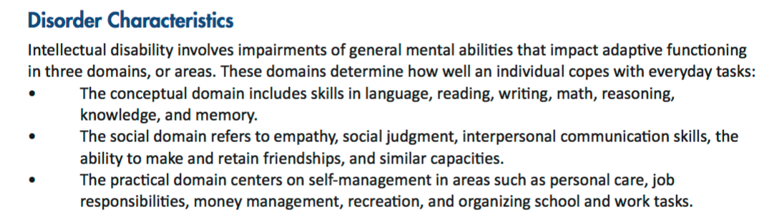

These medically- and psychologically-informed accounts present a stark, unyielding perspective on intellectual disability. They highlight what these individuals lack—what ‘normal’ tasks they cannot do and what ‘normal’ standards of intelligence they cannot live up to. But is this at all true? And even if it is, is that how we should be defining, delimiting the human experience of these people? Unsatisfied and angered by this perspective, we can turn to other, more progressive takes on intellectual disability:

In the *New York Times* article, “The Strange Case of Anna Stubblefield,” we are introduced to the practice of “assuming competence.” This orientation counteracts prejudiced assumptions about people with intellectual disabilities by instructing us to enter these relationships from a place of assumed ability instead of assumed lack. This is, as the article terms it, “the least dangerous assumption” (Donnellan qtd. in Engber). It comes from a place of humility and compassion, and it does not reify an ability power imbalance.

In the article, “More Intellectually Disabled Youth Go to College,” *The Huffington Post* presents a more inclusive perspective on disability by showing that people with intellectual disabilities can go to college and succeed within higher education. Although the article becomes quite problematic in the way it reinforces stereotypes about people with Down syndrome as childlike or always happy, it does challenge the discriminatory notion that intellectual disability and college education are incompatible.

**But are these perspectives enough?**

**Do they do enough to loosen the power that ‘proving smartness’ holds over both neurotypical and neurodivergent minds alike?**

**According to scholars Zeus Leonardo and Alicia A. Broderick, in their essay, “Smartness as Property,” the answer is no.**

Although they do state that “a presumption-of-competence stance may be understood as a necessary precondition for educating all children,” this perspective alone does not have enough force to dislodge the gatekeeping measure of smartness, competence, and coherence in determining who can be understood and who cannot (Leonardo and Broderick 2223). “If competence or smartness is understood as cultural capital, commodity, or property,” they explain, then “it is theoretically untenable that everyone could attain access to these material spoils of such an ideological system” (Leonardo and Broderick 2223). So long as competence remains part of the equation at all, they tell us, then there will inevitably be some people who are allowed in and others who are kept out. After all, “competence, or intellect, or smartness are but halves of conceptual binaries—the ‘haves’ require the ‘have nots’” (Leonardo and Broderick 2223). If this is true, then finding ways to open up the realm of smartness to *include* people with intellectual disabilities does not go far enough—not by a long shot. Even if we allow that adults with Down syndrome, like Zach Neff in *The Huffington Post* article, can navigate within the system of exclusive academic privilege that we have created, this does nothing to dislodge the **oppressive system of smartness** that remains intact.

But hold. On. What was that? The oppressive system of smartness? That is an idea worth unpacking.

**Unpacking the oppressive system of smartness**

*“We understand smartness to be a* ***performative****,* ***cultural ideological system*** *that operates in the service of constructing the normative center of schools and of societies, an ideological system that is nonetheless materialist not in any biological or neurological way, but rather in that developing an identity as either ‘smart’ or ‘not-so-smart’ is to have* ***very real material consequences*** *vis-à-vis one’s access and sense of entitlement (or not) to opportunities, privileges, and myriad forms of cultural capital—to* ***smartness as property****” (Leonardo and Broderick 2227).*

**Step 1: Smartness is a constructed concept.**

The concept of intelligence that exists today was not inevitable or inherent. Instead, it was carefully constructed—crafted to fit the needs of a particular social moment and the powerful actors operating within it. It was caught up in a whirlwind of statistics, bell curves, norms, and natural selection: The feverish desire to quantify and enhance humanity. Smartness is not natural or neutral (Hatt 442-43, Davis 1-5).

*“Intelligence emerged over time as a culturally produced notion tied to and imbued with relations of power.” –Beth Hatt, “Smartness as a Cultural Practice in Schools,” p. 442*

**Step 2: Smartness functions as a culturally-embedded system of meaning.**

*“Smartness is nothing but false and oppressive” (Leonardo and Broderick 2225)*

Once the conception of intelligence as measurable and quantifiable was put forth, it became deeply engrained in the fabric of schooling and the culture of educational spaces. In school, smart is pervasive. It is both an abstract notion and an embodied identity reinforced by experiences, interactions, and language that come to be associated with the realm of the smart. As Leonardo and Broderick observe: “A substantial part of the ideological work of schooling constructs and constitutes some students as ‘smart,’ while simultaneously constructing and constituting other students as ‘not-so-smart’” (Leonardo and Broderick 2214). In this way, the process of labeling smartness has been built into our educational system.

But what does smartness signify? If the idea of intelligence that we have come to accept is itself faulty and flawed, then what does it mean to be ‘smart’ in today’s school context? Turning to scholar Beth Hatt’s ethnographic work in a kindergarten classroom, we find that designations of smartness are often connected to a student’s ability to follow rules (Hatt 448)— to be a “’docile body’” submissive to the teacher’s authority (Foucault qtd. in Hatt 449). What’s more, “being smart [is] exhibited as prior knowledge as well as fulfilling teacher expectations” (Hatt 453). It is determined by a student’s capacity to meet certain predetermined standards. Far more than a label, smartness is part of a larger system of meaning; it has a crucial symbolic significance. “Being viewed as smart [leads] to gains in power, authority, and autonomy,” Hatt writes (Hatt 453). It profoundly impacts the way we understand ourselves and the roles we are capable of playing in the social world. It “shapes our own self-perceptions of efficacy, ability, and success in relation to academic potential, performance, and achievement” (Hatt 439). To be smart is to have power and privilege. It is to be visible and valued both in the classroom and in larger society. For those not granted access to this exclusive club, however, the result is invisibility and a lack of credibility.If you are not smart, then why should your ideas get to count?People with intellectual disabilities occupy a crucial space within this erased group. Since they do not usually perform smartness in a way that is recognize and validated by the education system, their intelligibility and autonomy are undermined. This erasure of personhood is strikingly similar to the way in which theory of mind (ToM) is used to “wreak violence on autistic bodies,” as Melanie Yergeau writes in her essay, “Clinically Significant Disturbance” (Yergeau). Because autistic people are said to lack theory of mind, their “agency,” their “humanity”—even their ability to communicate about their experiences—are called into question (Yergeau). In much the same way as ToM is applied here, labeling intelligence is a way to devalue ‘not smart’ people, including those with intellectual disabilities.

**Step 3: Smartness is inextricably tied to whiteness.**

Beyond recognizing the hegemonic power of smartness in its own right, Leonardo and Broderick take the crucial next step of recognizing how the system of smartness it is closely connected—indeed perpetually bound—to ideologies of whiteness and racial oppression.

Exploring the intersections….

**1. Whiteness and smartness are both employed by the dominant social group in order to oppress ‘the other.’**

“Like the derogation of people of color under White supremacy, smart supremacy derides the ‘intellectually disabled’ figure” (Leonardo and Broderick 2222)

**2. Neither whiteness nor smartness are based in biological fact. They are vacuous constructs that have been molded into realities, with very tangible results.**

“’Smartness’ is not an inherent physical feature of individual brains, not a ‘stuff’ or a ‘quantity’ that some people have more of than others, no more so than ‘Whiteness’ is an inherent physical feature of white bodies. Yet the ideology of smartness is inextricably intertwined in the creation of Smart people (as an identity) just as the ideology of Whiteness is inextricably intertwined in the creation of White people (as an identity).” (Leonardo and Broderick 2227)

**3. Whiteness and smartness exist only in opposition to what they are not.**

“Just as Whiteness is parasitic on blackness or colorness, smartness requires its dialectical opposite and cannot exist without the cursed population of so-called low intellect” (Leonardo and Broderick 2222)

**Naming and knowing the intersection of whiteness and smartness matters.**

Oppression is multifaceted and intersectional. This is what makes it so powerful: There is no one thread that can be pulled to unravel it all. Yet, by expanding our understanding of these systems to account for their interconnectedness, we bring the possibility of real change closer into reach.

Leonardo and Broderick end their paper with a call for the “abolition and whiteness and smartness” (Leonardo and Broderick 2225) They emphasize that these two systems must be destroyed in tandem, for “theoretical and political efforts to address one system of oppression without simultaneously addressing the other…are incomplete at best and actively…oppressive to others at worst” (Leonardo and Broderick 2226).

Certainly, there are many more systems of oppression at work here than just the two put into conversation by these scholars. Gender, sexuality, class, religion and many other identity markers all factor in.

Oppression is intersectional. Radical change must be, too.

Uprooting systems of oppression.

**Beyond smartness?**

Let’s frame smartness in the same way that Yergeau frames theory of mind. In her essay, she acknowledges that this theoretical frame was not built for her. It cannot account for the complexity of her existence. Yergeau does not attempt to squeeze the autistic mind within the tightly-bound package of ToM. She does not placate, does not compromise. Her mission is far more revolutionary than that. She chooses not to buy into ToM at all, to situate herself as outside of that intellectual imprisonment.

Is there a similar stance to be taken in terms of intelligence?

Just as Yergeau calls us to “dismantle theories about ToM,” could we also work to **dismantle theories about smartness?**

The real question is NOT “are people with intellectual disabilities smart?”

In fact, this approach completely misses the point.

The **real question** is why we insist on bringing intelligence in the conversation in the first place. Why is individual worth so caught up in this assessment of perceived smartness or lack thereof? Can smartness ever be truly known, quantified, held, touched, measured at all?

**What if** we didn’t need smartness to tell us whose stories are worth knowing, whose experiences are “real” or “credible?” Why do we **cling** so tightly to smartness if it

Doesn’t

Even

Exist?

**Letting Go…**

In his book, *Look, a White,* philosopher George Yancy asks white people to “tarry” with their whiteness—to recognize their embodiment of oppression and the privileges this provides them (Yancy 174).

I will add another layer to this request: That those of us operating within academia must also “tarry” with our smartness—with the weight of that distinction.

My whiteness is an invisible source of advantage. It passes unnoticed, yet confers upon me safety, authority, respectability.

My smartness is a more overt form of privilege. Unlike whiteness, which is defined by its ability to pass unmarked, my smartness is an active assertion. It requires constant praise, constant action, constant reaffirmation.

What would it mean for me to let go of these privileges?

Who would I be without them?

Since my whiteness has been such a silent source of power, it is hard for me to even imagine what it would be like to exist without it. The thought of giving up smartness, on the other hand, is visceral and all too real.

Smartness gives me confidence, gives me value, gives me purpose.

Smartness is protection, armor, a defense against my own self-critical mind. Smartness is what got me into Haverford College, it is what will give me opportunities, accolades in the future. Am I willing to give up this illusion of myself as somehow more capable, more worthy than everyone who didn’t make the smartness cut? Am I willing to lose the superiority of smart, and could I ever undo the years of schooling (a.k.a. smartness boot camp) that drilled this mentality so forcefully into my brain? What would it mean for me to truly, earnestly see myself as no better, no smarter than any other being—neurotypical and neurodivergent, anyone and everyone?

I don’t know.

I don’t know.

But I can try.

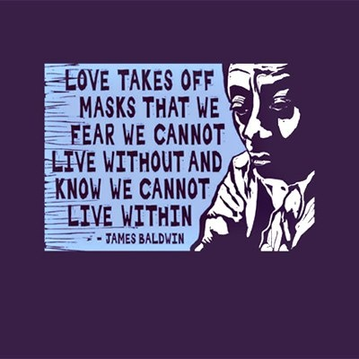

Works Cited

Davis, Lennard J. “Introduction: Normality, Power, and Culture.” *The Disability Studies Reader.* 4th ed. New York: Taylor & Francis, 2013. Web. 7 March 2016.

Engber, Daniel. “The Strange Case of Anna Stubblefield.” *The New York Times.* The New York Times Company,20 Oct. 2015. Web*.* 7 March 2016.

Hatt, Beth. “Smartness as a Cultural Practice in Schools.” *American Educational Research Journal* 49.3 (2012): 438-460. Web. 5 March 2016.

Hollingsworth, Heather. “More Intellectually Disabled Youths Go to College.” *huffingtonpost.com.* TheHuffingtonPost.com, Inc., 17 Oct. 2010. Web. 7 March 2016.

“Intellectual Disability.” *dsm5.org.* American Psychiatric Association, 2013. Web. 5 March 2016.

Leonard, Zeus and Broderick, Alicia. “Smartness as Property: A Critical Exploration of Intersections Between Whiteness and Disability Studies.” *Teachers College Record* 113.10 (2011): 2206-2232. Web. 5 March 2016.

Nigatu, Heben. “25 Powerful Quotes From James Baldwin To Feed Your Soul.” *buzzfeed.com.* BuzzFeed, Inc., 2 Aug. 2013. Web. 7 March 2016.

“Outlook for Children with Intellectual Disabilities.” *healthychildren.org.* American Academy of Pediatrics, 21 Nov. 2015. Web. 5 March 2016.

Yancy, George. *Look, a White!* Philadelphia: Temple University Press, 2012. Print.

Yergeau, Melanie. “Clinically Significant Disturbance: On Theorists Who Theorize Theory of Mind.” *Disability Studies Quarterly* 33.4 (2013): n. pag. Web. 7 March 2016.