From Complexity to Emergence and Beyond:

Towards Empirical Non-Foundationalism as a Guide for Inquiry

Paul Grobstein

Department of Biology
Bryn Mawr College
Bryn Mawr, Pennsylvania

Soundings 90 (1/2): 301-323
December 2007
Abstract

Emergence can be seen part of a continuing history of progressively increasing sophistication at inquiry, scientific and otherwise. Here I use my own career path as a way of showing how the emergence framework grew from and extended the earlier complex systems perspective, and how it in turn can be further developed in the direction of “non-foundational empiricism,” a form of inquiry in which one can explore and develop new ideas about inquiry itself by taking advantage of the story telling features of the human brain. The latter are themselves a product of emergence but make it possible for intention to influence future developments.

Emergence is increasingly “in fashion” (Resnick, 1994; Holland, 1999; Johnson, 2001; Keller, 2003), as was complexity fifteen years ago (Waldrop, 1992) and systems theory (von Bertalanffy, 1968), cybernetics (Wiener, 1948), and unified science (Reisch, 2005) among other things before that (cf. Clayton, 2006). In the case of emergence, as with its predecessors, different people are drawn for different reasons to a something that isn’t exactly the same for each person but instead reflects to varying degrees varying senses of dissatisfaction with existing paradigms for asking and answering questions. In this important sense, emergence exists because of emergence – because of inquiry as an emergent process -- and so has a somewhat different shape and character for different people and different more or less agreed on characteristics at different times.

This essay is about my own evolution as an inquirer and about how discussions of first complexity and then emergence both contributed to that evolution and suggested a path for its further development. As I hope will be clear by the end of this piece, I adopt this autobiographical approach not because I think there is anything particularly important about myself or my own experiences but rather because the story I have to tell itself implies that both the historical and the personal play much more significant roles in inquiry – and understanding -- than has yet to be fully appreciated. From this emergence perspective, my task is not to tell a completed story but rather to provide from my own experiences material that others can use to further evolve their own trajectories of inquiry. I hope that the story of “empirical non-foundationalism” serves that function.

A Personal Starting Point ...

Three general ideas permeated the environment when I was a young scientist in the 1960’s and 70’s. One was that the surest route to understanding involved focus and specialization. Paying attention to fields of inquiry other than one's own was, to put it mildly, not regarded as a productive way to invest one's time. A second foundational idea was that understanding more complex phenomena would follow necessarily from isolating and fully characterizing simpler phenomena that gave rise to them. And a third was that reality (or at least that subset of it that was treated at any given time as within the sphere of rigorous inquiry) was in fact understandable by such an approach, that is that there actually was a well-defined and unique set of properties and rules the discovery of which would progressively make the mysterious and not yet understood more predictable and ultimately completely so.

It was a perfectly reasonable set of ideas given the state of science at the time, one that created an environment within which many people were not only comfortable but prosperous and quite productive. However I became increasingly skeptical of it, as suggested by the following quotations from a paper I published almost twenty years ago (Grobstein, 1988)

" ... important aspects of both morphogenesis and brain function (and probably evolution and the immune system as well) are determined not by anything idiosyncratic to these particular systems but rather by some more general set of rules and principles to which they are all subject ... " (p 969)

"The myth that analysis at finer and finer levels of detail is the objective of studies of morphogenesis and brain function has been effectively driving research for a long time ... the present discussion implies that what is needed in both cases is to identify the involved semi-isolated systems at various levels of organization and to characterize the interactions among them. (p 966)

"Both morphogenesis and brain function behave to a significant extent as parallel, distributed information processors ... " (p 970)

"... variance is fundamental rather than either incidental or detrimental to successful biological organization ... without variance the generation of novelty which is so important ... to sustained organization in the face of an unpredictably varying environment [would] be lost." (970)

"It may be time to discard the metaphors of the machine age for not only the health of the biological sciences but that of our culture and species as well."(p 970)

My sense was that there were important patterns visible across fields of inquiry that were being missed by getting caught up in the idiosyncracies of individual perspectives. At least as important, in hindsight, was a developing distaste for the notion that there was a way to engage in scientific inquiry that was already known to be right and an even greater distaste for the idea that inquiry in turn was itself simply a process of uncovering things that already exist. Both science and the world, it seemed to me, not only must be more interesting than that but seemed, in fact, to be empirically proving to be, at least in the fields I was then working in (see also Grobstein, 2007a).

Recognizing commonalities in several interacting levels of "parallel, distributed information processors" and allowing for a significant role for "variance" seemed to me open things up a bit in useful ways. It also opened things up for others in the evolving area of what was then called "complex systems" (the Santa Fe Institute was founded in 1984; Parallel Distributed Processing was published in 1986 (Rummelhart et al, 1986)). My personal touchstone at this time was the phrase

Simple things interacting in simple ways can yield surprisingly complex outcomes (Serendip. 1995)

This general principle had itself recently become empirically demonstrable because of the ready availability of computers that allowed one to easily and quickly explore the consequences of simple interactions of simple things in a way never before possible (Serendip, 1995). While that didn’t itself challenge the older idea of trying to make sense of the behavior of wholes in terms of parts that made them up, it did provide an explanation for the increasingly common finding that there was no simple relation between wholes and parts: one ought not to be looking for parts that had the same properties as wholes (what I called “naïve reductionism” (Grobstein, 1988, p 962)) but rather for parts with other sorts of properties, not necessarily either predictable or unique, that yielded by their interactions the observed properties of the whole. The focus on interactions also indicated that working exclusively downward from wholes to parts could be missing significant aspects of what was going on: Interacting parts yield new properties of wholes that could in turn be important influences on the parts. One needed to work both downward and upward from any given starting point (cf Grobstein, 1990 for a particular concrete example).

More generally, complexity achieved through interactions began to create a challenge to the notion that understanding could be equated absolutely with predictability, a challenge still more serious if one allowed for not only complexity in interactions but also for some measure of genuine indeterminacy in either parts or interactions or both (Grobstein, 1994). This might not be quite enough to justify “discarding the metaphors of the machine age” as a foundation for inquiry but it pointed that way and laid some important groundwork for later movements in that direction as discussed below. Finally, the complexity perspective certainly encouraged the notion that there might be similar explanations of similar phenomena in quite different realms.

An Illustrative Case ... The Complex Systems Perspective

One can't help but notice a similar pattern, ripples, in the photographs of Figure 1. They are in fact though quite different phenomena occurring at quite different scales. One is a landscape pattern on Titan (one of Saturn’s moons), another a sand dune pattern in Africa, the third a pigmentation pattern on a zebra, the fourth a cloud pattern, the fifth a pattern in water (being used as an illustration of aspects of economic change), and the sixth a sand pattern in a Zen garden.

Is it useful to entertain the idea of a similar understanding of all of these disparate patterns, something that transcends the idiosyncracies of meteorology, geophysics, biology, and culture? And, if so, what would a "similar understanding" look like, and how useful would it be? One possibility of course is that that there is some single outside agent that had that pattern in mind and so shaped all these different materials similarly. Most scientists (myself included) discounted that possibility and continue to do so, but it is worth mentioning for reasons I will come to shortly. Could there, though, be some general form of "simple interactions of simple things" that is instantiated in all these different cases and so yields the ripple pattern observed in all of them?

That's the sort of question that a "complex systems" perspective encourages. The existence of "flicker noise" in a variety of different systems is a similar though more abstract example (Bak, 1999). And it has been demonstrably a productive question to ask. Alan Turing, having noticed similar pigments patterns in a variety of different organisms produced a classic paper describing a set of diffusion equations that would yield ripples, among other things, when applied to any of a wide variety of constituents (Turing, 1952; see also Wilensky 2003). And there are other sets of formalisms that link together in likely ways dune formations on Earth and on Titan despite their very different physical constituents and conditions. On the flip side, some ripple patterns certainly involve one set of formalisms and others others. Some things turn out to be usefully linkable together using the "complex systems" perspective, others not. The "complex systems" perspective can, it has turned out, be a useful adjunct to more idiosyncratic perspectives but is not a replacement for them.

Useful as the "simple things interacting in simple ways" insight was and continues to be, (see Greif, 2007) a truly general set of "properties and rules" that can be similarly and equally effectively used across all spheres of inquiry did not result from it. And, despite intermittent enthusiasms about one or another “theory of everything,” it seems increasingly unlikely it ever will, for two somewhat different reasons. One has to do not with the presence or absence of a general theory of everything but rather with a deeper problem that arises from the emergence perspective: when it is and is not appropriate to think about things in terms of “properties and rules” at all. The other has to do with the Zen garden ripple patterns of Figure 1. While one can might comfortably imagine that each of the other ripple examples in the figure can be accounted for by one or another set of simple interactions of simple things, the Zen garden pattern would seem to be different, to involve something more, something with an overall intent or purpose. What’s different in this particular case, and how are we to make sense of that?

Looking Slant: The Emergence Perspective

"By starting from wholes and moving down into parts, one is moving in the opposite direction from which things arise." (Goodenough and Deacon, 2006, p 854)

The complex systems perspective starts from existing phenomena and asks for an explanation of them in terms of interactions among simpler components, and then for an explanation of those in terms of interactions among still simpler components, and so on. It differs from "naive reductionism" in significant ways but is not in and of itself a direct challenge to the notion that the goal of inquiry is "a well-defined and unique set of properties and rules the discovery of which would progressively make the mysterious and not yet understood predictable.” The complex systems perspective did, however, contain the seeds of a challenge to even more sophisticated forms of reductionism, particularly in its recognition of the possible significance of indeterminate processes and of the possibility of wholes affecting parts, that is top-down influences.

For me, the important next step from the complex systems perspective to what I would call the "emergence" perspective has to do with recognizing that “simple things interacting in simple ways yields complex outcomes” may in fact be more than a (sometimes useful) tool for discovering ways to account phenomena of interest. Rather than understanding it as an inquiry strategy – take more complicated things apart to discover their underlying properties and rules – it might instead be taken as a description of how things come into existence in the first place, leaving as an open question whether they will or will not turn out to be well described in terms of properties and rules. Along this path my own personal touchstone for emergence has been

“organization can exist without either a conductor or an architect” (Grobstein, 2004).

The "ripples" illustrated and talked about in connection with the complexity perspective serve equally to make clear this new notion in the emergence perspective. There was, most of us presume, no one on the surface of Titan delivering directions to the grains of whatever is there to position them in orderly arrays, no "conductor", much less anyone with any intention, any picture in mind, of how they wanted those grains to be organized (no "architect"). Those patterns (and similar ones on our own beaches, lakes, and skies) have no explanation OTHER than "simple things interacting in simple ways.”

The "conductor, no architect" principle is not hard for most people to accept with regard to ripples. Its significance becomes clearer though with its successful and surprising application to a wide range of other phenomena, including processes of cellular aggregation, flocking and synchronization in animal behavior, and a host of human social phenomena in which some sort of conductor and/or architect was expected to exist (Johnson, 2001; Keller, 2003; Grobstein, 2007a). We are not in general used to explaining things without invoking either an conductor or an architect, and that has clearly affected our ability to understand a wide variety of phenomena. This is not to say (as I will come to shortly) that we should never look for conductors or architects, but clearly more sophisticated forms of inquiry should not presume them.

Emergence as a "universal acid"?

The full blown emergence perspective is actually more subversive still, by several orders of magnitude. Like the perspective of biological evolution (which it grew from and closely resembles (see Dennett’s (1996) idea of evolution as a “universal acid”)), the emergence perspective raises the serious possibility that the origins of everything that currently exists lacked any architect, plan, or intention, and that as a consequence we cannot derive meaning from looking either backwards at origins or forwards towards some pre-existing goal. This is not so disturbing (for most of us) in accounting for ripples but can be quite disturbing with regard to other matters.

Particularly important, in the present context, is that the emergence perspective has some interesting and perhaps disturbing implications for thinking about inquiry. We may, if we want, choose to "explain" ripples in terms of "properties and rules," but those could well prove in fact to be constructions of our brains (which could themselves of course be emergent systems) and in any case played no role whatsoever in the formations of the ripples which, we presume, would exist not only in the absence of a conductor and an architect but also in the absence of any inquirer into them. And this in turn raises the difficult question of whether the “properties and rules” we come up with are actually intrinsic characteristics of the things we inquire into or are instead simply one of many possible ways to make sense of things (Grobstein, 2003; 2007a, b; Stanford, 2006; see also Grobstein, 2006). If the properties and rules approach and emergence theory are actually different ways of making sense of the world, then the very concept of accounting for things in terms of “properties and rules” may itself need an emergent explanation and so cannot be taken as a certain ground for inquiry. Further, it is possible that properties and rules may fail to provide a sufficient explanation of things. In light of that failing, emergence theory may offer the only credible way we have to describe the world. That is, not only are particular examples of "properties and rules" challengeable but the concepts of "properties and rules" themselves are challengeable as ways of making sense of things.

The key issue here is whether not only the phenomena we inquire into but we ourselves as inquirers can in principal be fully accounted for by underlying “properties and rules” that we are capable of discovering. If so, one is dealing with “weak ermegence” (Clayton, 2006, p 7), a straightforward extension of complexity that acknowledges that phenomena of inquiry (including inquiry itself) may reflect huge numbers of subtle interactions but asserts that they are in principle reducible to some singular set of underlying properties and rules from which everything else, including inquiry and its products, follows necessarily (see Wolfram, 2002). “Strong emergence” (Clayton, 2006, p 7), on the other hand, allows for the possibility that things may come into existence that do not follow necessarily from previously existing things and any “properties and rules” associated with them, and that these in turn may have top down causal efficacy. There is no mysticism involved here, except for those committed by inclination or background to a deterministic reality based on a fixed set of underlying properties and rules. Strong emergence requires nothing more than a recognition that some degree of randomness plays a role in what comes into existence at later points in time can influence things that already exist. On the other hand, strong emergence gives on a markedly different way to think about inquiry, suggesting that it not only plays an inevitable role in how we characterize what we are inquiring into but may in fact create subjects of inquiry that would not otherwise have come into existence.

The emergence perspective thus raises discomfiting problems about not only the meaning of existence but also the nature of inquiry, but these problems seem to me to be an indication of its broad significance rather than a source of concern. The emergence perspective in its strong form does indeed challenge older ways of asking and answering questions, but it is not without guides to newer ways f asking and answering questions in its own right.

What is significant about emergence, seen as the source of what is to be explained rather than simply a way of explaining things, is its emphasis on the importance of historical explanation and on a pattern of ongoing creation of novelty. What is is what has emerged, somewhat unpredictably, from the past and in turn is the grist from which a significantly unpredictable future emerges. Both because of the inherent indeterminacy of the world and because of our always limited set of observations about it, we have no way to know whether what we inquire into actually has the characteristics we attribute to it at any given time, much less whether it will always have those characteristics. On the other hand, the emergence perspective not only encourages but requires the inquirer be situated within the process being explored, and so view her/himself as a potential additional contributor not only to uncertainty about it but also to its generation of novelty. This in turn suggests a need for reconsidering at fairly deep levels what is meant by understanding and how one might go about achieving it. From this perspective, neither predictability nor reducibility to a fixed set of “properties and rules” are appropriate general criteria by which to measure the success of inquiry. What is important is not only how well one the inquirer can account for the present and predict the future but the new things the inquirer brings into existence to be explored in the future.

Instead of being surprised by emergent phenomena and perspectives because they challenge the primacy of things like “properties and rules” one can take emergent phenomena themselves as the starting point and ask where do things like “properties and rules” and meaning come from, and what role do they play in the phenomena we observe? Inherent in this approach is a recognition that not all phenomena are simply emergent that is lacking in intention or design. Some (see figure 1) are clearly amenable to descriptions in terms of “properties and rules”, and understand how non-emergent things come into being in a n emergent way and how, once they do, they interact with ongoing fully emergent processes, with those processes lacking an architect and/or conductor. In the following, I sketch a sample program of inquiry along these lines.

A story of, and beyond, emergence:

Creations myths have been and continue to be among mankind's most powerful stories: In the beginning was ... the Word? the void? formlessness? My proposed creation story begins instead in the present, with all that one experiences around and inside one, all that one sees/feels/thinks/imagines. According to this story, inquiry begins and ends with those things. All else, including the "beginning", is hypothesis and conjecture, more or less well-founded but nonetheless ... story (Grobstein, 2005a, 2007b). That is not at all to say that there may not exist things beyond one's experiences, but it is to say that whatever descriptions we give of those things, indeed the very process of giving descriptions of them, is necessarily and inevitably derivitive of our experiences of them and for that reason challengeable based on additional experiences, our own or those we derive from other people.

Not all entities, the story continues, share our capacity to have experiences of things and the associated capabilities of conceiving of things in new ways and so questioning why they are rather than some other way. It is from such entities that "inquiry" itself emerges, and from that in turn that the idea of "properties and rules" emerges along with a host of other concepts like "the Word", "the void", "formlessness", and "meaning". The word "emerges" is deliberately used here. "properties and rules" could not have come into existence without the prior existence of "inquiry" and that, in turn, depended on prior experiences of things and in conceiving alternate possibilities for them.

Biology suggest that we have these capabilities and other entities don’t because of differences in material organization, in architecture, in the way the matter we are made of is assembled, rather than because of differences between the things that we and other entities are made of. Our own architecture shares features with those of other entities but seems more elaborate. Perhaps, my story goes on, we can make sense of all of this and much more by imagining a process of continual change, extending over very long periods of time, in which more complex architectures emerge, somewhat randomly and largely without either a conductor or an architect, from simpler ones.

A likely scenario for such a process of emergence that could account for our own existence and experiences of it is provided in Figure 2. Early in the process matter/energy existed only in relatively simple forms (sub-atomic particles, atoms, molecules) that influenced each other in relatively simple ways. There was, however, a large amount of random interaction among these simple entities that in turn produced larger entities of a variety of forms. This process of an ongoing production of relatively stable forms of matter/energy (the "active inanimate") extended over many billions of years and continues today.

A relatively short time ago (at least from the perspective of our solar system), the interactions of the active inanimate gave rise to new forms of organized matter/energy having new properties. These were the simpler and then progressively more elaborate forms of living things. This process too continued for an extended time, in the absence of any conductor or architect, driven only by random change and the relative persistence of more stable forms in comparison to less stable ones. Several factors contributed to relative stability. Among them was architectures that could be modified by interactions with other entities so as to make use of prior interactions to create and update internal representations of their surroundings. These were living things or "model builders". With the latter came as well an enhanced ability to alter the surroundings, both inanimate and animate, in ways that further stabilized the entities themselves. The model builders were hence "purposive" agents in the emerging universe. Though they themselves had no experience of purpose, they nonetheless functioned in rudimentary ways as conductors, and orchestrators of things around themselves.

A still shorter time ago, the ongoing explorations of the model builders gave rise to a still more elaborate architecture of the sort that we embody and that gives us (and probably some other organisms to varying degrees) the ability to inquire and all that follows from it. For the first time, there appeared not only the notion of an architect but the abilities to function as one by altering matter/energy. This included the ability to create stories (Grobstein, 2005a, 2007b) and hence to bring into existence forms of matter and energy that had not previously existed and might not come into existence without an intention or plan.

According to this creation story, what has emerged from a process originally lacking any conductor or architect are agents that can indeed act as both conductors and architects. In the beginning, there was no "Word" but there are now not only words but also rules, meanings, and a whole host of additional and interesting complexities because of them. We live not solely in an emergent world but in a hybrid one, a world in which architects and conductors have been brought into existence by emergent processes.

Blending the emergent and the architect: the bipartite brain

Though it is not normally thought of in this light (and frequently not thought of at all), human experience provides a clear indication of the existence within one system of both emergent properties and properties indicative of the exercise of the action of an architect. And, on the reasonable assumptions that human experiences reflect brain processes and that the human brain is largely a product of evolution, human experiences indicate as well not only that a hybrid of emergent and architect-dependent processes can result from architect free emergence but also that it can occur in a system rooted firmly in emergent function.

The human brain consists of a very large number of relatively simple elements (neurons) interacting in relatively simple ways by exchange of information across synapses. Hence, the brain’s function would be expected to have an emergent character to it. What seems to give the brain its additional function as an architect is a bi-partite arrangement (see Figure 3; Grobstein, 2007b) in which a series of model building elements (circuits of neurons) that interact directly with the world also report their activities to a second set of neuronal circuits that in turn use them to develop goals and alternative behaviors for the system as a whole. The former corresponds, more or less, to what may be conveniently referred to as the “unconscious” and the latter to “consciousness”. Behavior reflects continuing interactions between the two, and is normally an expression of the blending of the emergent and the architect. The interactive expression of both systems is not normally consciously experienced but sometimes becomes so in circumstances where the unconscious is inclined to act one way and the conscious another. The two systems can also be visibly disentangled by certain special behavioral circumstances and in cases of brain damage.

In addition to their different relations to the outside world, and the different ways they generate experiences, the two systems diverge in other ways particularly relevant in the present context. The unconscious system is capable of relatively rapid action, while the conscious one takes more time to act. More significantly, the unconscious system works with large numbers of different variables and with a high degree of parallel processing in special-purposes processors. Uncertainties and conflicts are not evident in the operations of the unconscious, which simply and quickly updates each of a series of relatively independent modules based on their local input/output/input histories. In contrast, the conscious system tries to create a “story” that brings overall coherence to the reported activities of the unconscious modules (Grobstein, 2005b). In so doing, it attempts to structure information in terms of a relatively small number of variables with relatively simple causal relations among them. This produces both an ability to rapidly conceive alternate possibilities and a preference for “rules”, with an associated concern for logical consistency and avoidance of conflict.

The significance of hybrid systems for inquiry

“"pragmatic multiplism" is not a characteristic of science alone, but rather is an inevitable and inescapable characteristic of all human inquiry into material things … because it is a fundamental aspect of the organization of the brain, which is itself the "inquirer"” (Grobstein, 2003, p 154)

Are “properties and rules” actually characteristics of those things “out there” that we are inquiring into or are they actually constructions of the brain? With a bipartite brain, one needn’t choose between the two forms of understanding. One can instead make use of both of them, summarizing observations in terms properties and rules when it seems useful, and not doing so when it does not.

The stability of model builders, and of model building functions in general, is clearly constrained by the kinds of patterns that have existed in their inputs in the past and hence depends to a significant degree on stability in their surroundings. What the story telling functions of the conscious make possible is an ability to conceive things beyond both the limits of the restricted patterns provided to individual model makers and beyond the restrictions inherent to past inputs. These capabilities can serve well both to anticipate future events and to influence them. From this perspective, what is significant about inquiry is not only the degree to which its stories account for the past in particular local situations but how well it recognizes additional patterns across wider realms in its own activities and how “generative” it is, how effectively it contributes to the ongoing explorations of what might be that characterize the larger emergent process of which inquiry itself is a part.

Hybrid systems and empirical non-foundationalism

I hope it is, at this point, clear why I have adopted an autobiographical approach in this essay, and why the brain has become a central part of it. It is a story of empirical inquiry, in which the subject of exploration includes inquiry itself and so observations on inquiry are germane. Moreover, it is a story of not just emergence, but of a hybrid system, myself, who is capable both of making and summarizing empirical observations and of reflecting on them in order to conceive ways of inquiring that might be still more productive, in the sense not only of accounting for a diversity of observations but also of creating new directions for exploration and inquiry.

The intended message of this story is not that inquiry based on reductionism, or on a presumption of underlying properties or rules is necessarily bad, anymore than one based on complex systems or emergence is. Each can be productive within certain domains, and demonstrably has been. Instead I want to suggest that each is limited and that the source of that limitation is a deeper presumption that the business of inquiry is to uncover “reality”, a stable thing outside of ourselves that we can describe without affecting it. What my own experiences suggest is that that presumption is itself flawed, that the business of inquiry is as much about creation as it is about discovery, that we ourselves are a result of and a continuing participant in a larger process of ongoing exploration/creation, and hence should not expect ever to achieve either a definitive description or properties and rules nor a definitive predictability. We should instead be at least content, and perhaps even exhilarated by, being ourselves creative participants in the very phenomena that we inquire into.

That may seem like a platitude, but it has real and concrete implications. Among them is that for inquiry in the broadest sense we need to learn to give up the concept of an achievable “Truth” or “Reality”, as well as any effort to measure successes by assertions of proximity to such things. We need instead to learn to be not only aware in principle that the answers to our inquiries are always tentative but to recognize that that is practically so and search for some criterion for success that doesn’t depend on such ideas. That is, we need to be “non-foundationalists”, willing and able to pursue open-ended inquiry without any crutches, including those that say there is a fixed objective to be achieved. That is not to say all directions are equivilant, but is to say that one will only know for certain which directions are more effective after the fact, when one can assess in hindsight their generativity.

Perhaps still more difficult, given our training, we have to give up our reflex inclination to try and assess which of multiple lines of possible inquiry is, at any given time, the “best” one and to defend that one (typically our own) by trying to destroy all others. In the long run, as empirical inquirers, we need to learn not only that there is no best approach to inquiry (as there is no best living organism) but that it is in fact from the existence of multiple lines of inquiry that new and more productive lines of inquiry are generated. It is not only our observations but our stories that we can usefully compare in search of new stories and new observations.

Testing empirical non-foundationalism

Empirical non-foundationalism is, for me at least, a new direction in inquiry, though one anticipated by the Greek atomists and skeptics. Inquirers need to be understood as creators as well as explorers, as interpreters (see Rorty, 1999) as much as revealers. And the issues are not only intellectual but also practical, as they must be if they are applicable in other realms, and so both further generative and testable.

One such realm is education (Dalke and Grobstein, 2007b, Dalke et al., 2007; see Figure 5). If empirical non-foundationalism is to be taken seriously, it implies that the primary task of education is not to convey to students either existing understandings or essential “skills”, as defined to social and cultural norms at any given time. The primary educational task is instead to encourage all students to develop their own individual inquiry abilities, their own inclinations to create and revise stories about themselves and the world around them, and to share those stories as part of a continuing process of creation of new and “less wrong” stories, with no presumption that anyone, themselves included, will ever be “right.” This in turn suggests that there need to be quite substantial changes in classroom dynamics and practice (See Anne Dalke’s article in this volume), with the teacher becoming partially a student and the students becoming partially teachers, in order to work together in a continuing process of “open-ended, transactional inquiry.” Can this be achieved? Would it be successful within particular societies and cultures? For the students? For the cultures and societies themselves? This is one test of the usefulness of the story of empirical non-foundationalism.

A second realm where the story of empirical non-foundationalism has implications that can be tested is in social organization more generally (Grobstein, 2007a, see Figure 4). The emergence story represents a serious challenge to presumptions that hierarchical authority systems are either optimal or inevitable forms of social organization, not only in the classroom but through out societies. The story opens the possibility of genuinely distributed authority, in which individuals come to recognize the benefits for themselves of both pursuing their own distinctive paths of inquiry and of having others around them doing the same thing. In such truly pluralistic cultures, some will explore narrower terrains and others broader ones, with all contributing to the work of all. Can a culture of this kind be brought into being? Would it be not only stable but in turn generative of new kinds of cultures? This is a second test of the usefulness of the story of empirical non-foundationalism.

Reflecting on the past to create the future

Empirical non-foundationalism is the product of my own experiences as a scientist and inquirer. It is itself both an emergent story, drawing on the work of others in both complex systems and emergence, and a hybrid story shaped by my own observations, reflections, and aspirations. For myself, it generates new questions and challenges in its own terms: Is it actually true that emergent systems can yield planners and architects? Is the picture of the brain as a hybrid system actually accurate? In broader contexts, can one actually found effective educational and social systems on a profound sense of the limitations at any given time of the products of inquiry?.

My purpose in telling the story is not to persuade others to accept empirical non-foundationalism, but rather to offer some tools I’ve found that may be useful in their own story telling and story revising, and to encourage others to engage in their own inquiries. Among the specific tools I have found useful are

- Simple things interacting in simple ways can yield surprisingly complex outcomes
- Meaningful organization can exist without either a conductor or an architect
- Inquiry is about getting it “less wrong” rather than “right”
- Inquiry is as much about conceiving new possibilities as it is about discovering what is.
- Inquiry is facilitated by encouraging the development of different stories that can be compared and contrasted to yield new possibilities.

Clearly, the foundational ideas with which I began my own career of inquiry have gone by the wayside. No, one shouldn’t necessarily work only from a narrow focus; a broader view can see possibilities less visible from more closely defined perspectives. No, one doesn’t seem to be able to account for more complex phenomena simply by studying simpler ones; interesting phenomena are too complex and variable for that. No, reality is not and will not be accounted for by a fixed set of properties and rules; it is changing all the time, in part because of our own activities as inquirers. But the foundational ideas I started with are still usable in many narrower contexts and, still more importantly, recognizing and being dissatisfied with them played an important role in propelling me to my current understanding of inquiry, and of humanity and our place in the universe. My dissatisfaction generated new questions from which new stories can reasonably be hoped to emerge. If the story I have told helps others to do the same thing, it will have fulfilled its purpose. Giving up “foundationalism” in any and all forms may make it harder to achieve consensus in understandings, but it offers, in return, the potential of new and productive ways of seeing things. We are all inquirers, following interacting but also unique trajectories that reflect our distinctive histories and personalities. Both the uniquenesses and the intersections are essential parts of the larger process of somewhat unpredictable generative inquiry in which we are all involved.

Acknowledgements. My thanks to faculty and student colleagues in the Emergence Working Group at Bryn Mawr College for several years of generative conversation without which this essay would not have existed. My thanks too to the editor of Sounding, to the editors of this special issue, and to anonymous reviewers all of whom contributed importantly to this essay.

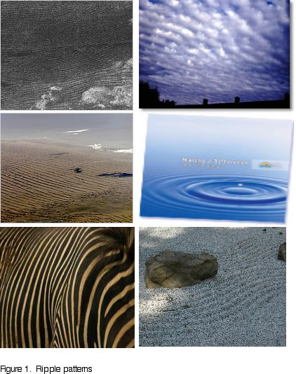

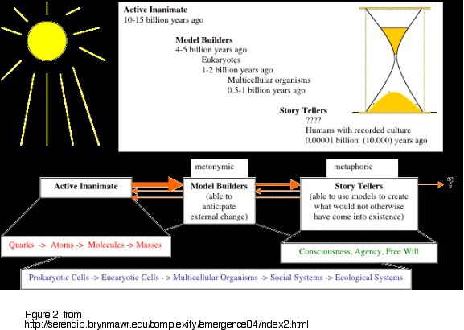

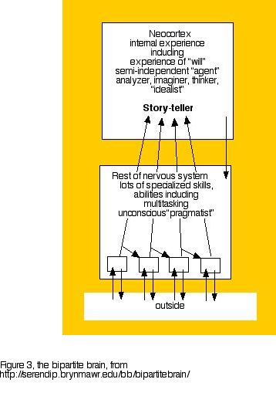

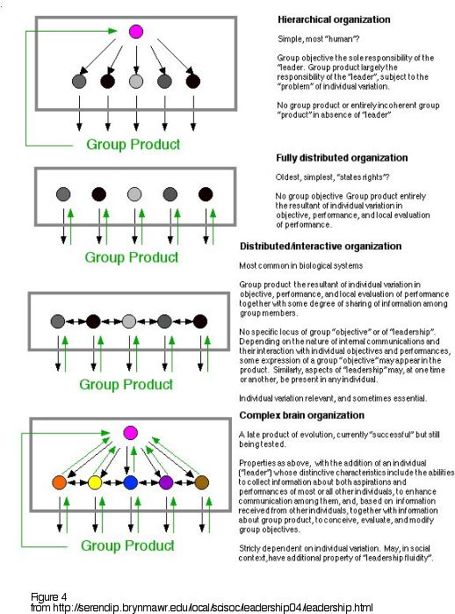

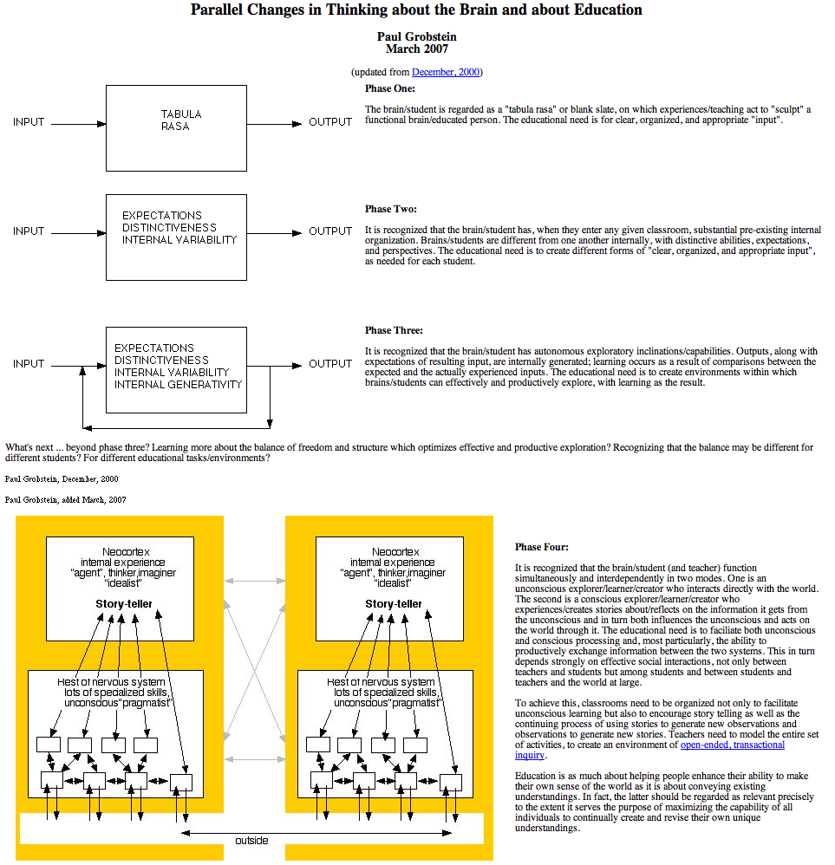

Figure 5. from http://serendip.brynmawr.edu/sci_edu/brainedparallels.html

References

Bak, Per (1999) How Nature Works, NY: Copernicus, 1999.

Clayton, P. (2006) Conceptual foundations of emergence theory. In: The Re-Emergence of Emergence. P. Clayton and P. Davies, eds. Oxford: Oxford UP. 1-31.

Dalke, Anne. and Grobstein, Paul (2007) “Story Telling in (At Least) Three Dimensions: An Exploration of Teaching Reading, Writing, and Beyond.” Journal of Teaching Writing, forthcoming.

Dalke, Anne, Cassidy, Kim, Grobstein, Paul and Blank, Doug (2007) “Emergent Pedagogy: Learning to Enjoy the Uncontrollable and Make it Productive.” Journal of Educational Change, 82(2): 111-130.

Dennett, D. Darwin’s Dangerous Idea, New York: Simon and Schuster, 1996.

Holland, J. Emergence: From Chaos to Order. Reading, Mass: Addison-Wesley, 1999.

Goodenough, U, and Deacon, T.W. (2006) “The Sacred Emergence of Nature.” Oxford Handbook of Religion and Science. P. Clayton and Z. Simpson, eds. Oxford UP. 853-871.

Greif (2007) this issue

Grobstein, Paul “From the head to the heart: some thoughts on similarities between brain function and morphogenesis, and on their significance for research methodology and biological theory.” Experientia 44: 961-971.

Grobstein, Paul (1990) “Strategies for analyzing complex organization in the nervous system. I. Lesion experiments the old rediscovered.” Computational Neuroscience. E. Schwartz, ed. New York: Academic Press. 19-37.

Grobstein, Paul (1994) “Variability in behavior and the nervous system.” Encyclopedia of Human Behavior, Volume 4. V.S. Ramachandran, ed. New York: Academic Press, 447-458.

Grobstein, Paul (2003) “Getting it less wrong, the brain's way: science, pragmatism, and multiplism.” Interpretation and Its Objects: Studies in the Philosophy of Michael Krausz. A. Ritvoi, ed. Amsterdam: Rodopi. 153-166.

Grobstein, Paul (2004) “Emerging Emergence.” Retrieved 15 October 2007 from http://serendip.brynmawr.edu/comlexity/emergence04

Grobstein, Paul (2005a) “Revisiting Science in Culture: Science as Story Telling and Story Revising.” Journal of Research Practice 1.1, Article M1.

Grobstein, Paul (2005b) “Making the Unconscious Conscious, and Vice Versa:
A Bi-directional Bridge Between Neuroscience/Cognitive Science and Psychotherapy?” Cortex 441: 663-668.

Grobstein, Paul (2006) “The Nature of Science: The ‘Problem of Unconceived Alternatives’ and its Significance.” Retrieved 15 October 2007 from http://serendip.brynmawr.edu/sci_cult/stanford.

Grobstein, Paul (2007a) “Paths to Story Telling as Life: Fellow Traveling with Richard Rorty.” Retrieved 15 October 2007 from http://serendip.brynmawr.edu/exchange/rorty.

Grobstein, Paul (2007b) “Interdisciplinarity, Transdisciplinarity, and Beyond: The Brain, Story Sharing, and Social Organization.” Journal of Research Practice 3.2, Article M21. Retrieved 31 October 2007 from http://jrp.icapp.org/index.php/jr/artlce/view/98/92.

Jacobs, Jane. The Death and Life of Great American Cities. New York: Random House, 1961.

Johnson, S. Emergence: The Connected Lives of Ants, Brain, Cities, and Software. New York: Simon and Shuster, 2001.

Keller, E.F. Making Sense of Life: Explaining Develoment with Models, Metaphors, and Machines. Cambridge: Harvard UP, 2003.

Reisch, George A. How the Cold War Transformed Philosophy of Science: To the Icy Slopes of Logic. New York: Cambridge UP, 2005.

Resnick, M. Turtles, Termites, and Traffic Jams. Cambridge: MIT Press, 1994.

Rorty, Richard. Philosophy and Social Hope. New York: Penguin, 1999.

Rumelhart, D.E., J.L. McClelland and the PDP Research Group. Parallel Distributed Processing: Explorations in the Microstructure of Cognition. Cambridge: MIT Press, 1986.

Serendip (1995) Complex Systems. (updated since) Retrieved 13 April 2007 from http://serendip.brynmawr.edu/complexity/.

Stanford, P.K. Exceeding Our Grasp: Science, History, and the Problem of Unconceived Alternatives. New York: Oxford UP, 2006.

Turing, Alan (1952) “The chemical basis of morphogenesis.” Phil. Trans. Roy. Soc. B: 37-72.

Von Bertalanffy. General System Theory. New York: Braziller, 1968.

Waldrop, R.M. Complexity: The Emerging Science at the Edge of Order and Chaos. New York: Simon and Shuster, 1992.

Wolfram, S. A New Kind of Science. Champaign, Illinois: Wolfram Media, 2002.

Wilensky, U. (2003) NetLogo Fur Model. http://ccl.northwestern.edu/netlogo/models/Fur. Retrieved 13 April 2007.

Wiener, N. Cybernetics or Control and Communication in the Animal and Machine. Cambridge: MIT Press, 1948.

