Jen’s “foremothers:”
thinking back through feminist scholarship,
cultural difference, and resistance

Foucault’s Discipline and Punish blew my mind in college. Some people find him depressing, but – as I recall – I think I was jazzed by the idea that the most intimate, even bodily ways in which we define ourselves, our experience, and our own desires are always shaped within a field of discipline. Like many people during college, I think I was thinking a lot about my “self” those days and how I wanted to experience it…Foucault doesn’t provide any easy answers about self-recreation, but I have always found his focus on the minute details of everyday (especially institutional) life to be useful towards at least being able to reflect in new and startling ways about our own standards for ourselves, our senses of what is normal, necessary or desirable, and how they position us within broader contexts of power.
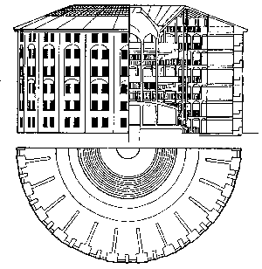
Bentham’s panopticon

I’m not sure whether Foucault qualifies as a “feminist foremother,” but here is a taste from D&P:

…normalization becomes one of the great instruments of power at the end of the classical age…In a sense, the power of normalization imposes homogeneity; but it individualizes by making it possible to measure gaps, to determine levels, to fix specialities, and to render the differences useful by fitting them one to another. It is easy to understand how the power of the norm functions within a system of formal equality, since within a homogeneity that is the rule, the norm introduces, as a useful imperative and as a result of measurement, all the shading of individual differences.

But it was my interest in the Soviet Union that led me most directly to anthropology.

I wanted to participate in fostering meaningful communication between the USSR and the US – remember, this is the (tail-end of the) Cold War. Our governments are bad but if we learn to speak each other’s languages (figuratively speaking), we can relate to one another peacefully, on a person-to-person level, and encourage some kind of change…such was my thinking.

Along the way, the Cold War ended, I went to study abroad in Russia, and I also became a Women’s Studies concentrator…
I began thinking about what “feminism” looks like cross-culturally. In the post-Soviet Russian context, the problem U.S. scholars were talking about was that Russian women did not want feminism – certainly not feminism as it being talked about in the West (although Russian women’s conceptions of feminism were often highly stereotyped – as are American women’s).

One explanation for this is that people felt they had already had feminism; in fact, it had been forced upon them. The October Revolution (1918) had instituted a wide range of social reforms along with the repressions of which we more often hear. These included a number of measures designed to put women on an equal footing with men (remember the Marxist critique of women as the proletariat to men’s bourgeoisie within the capitalist family):

--universal access to education, health care
--full participation of women in the public work force
--support for families, including maternity leaves and public childcare
--relatively “androgenous” portrayals of women in official media
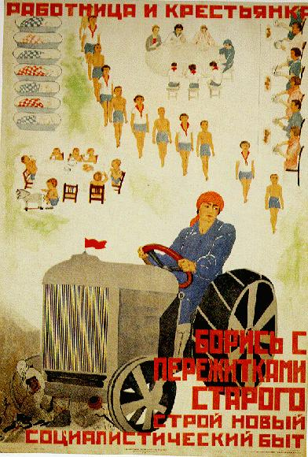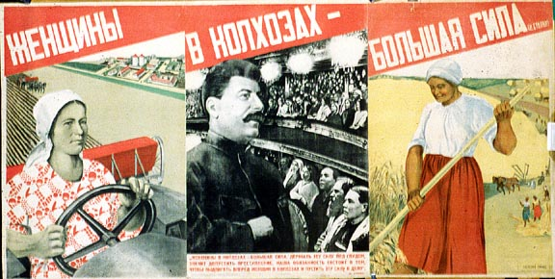
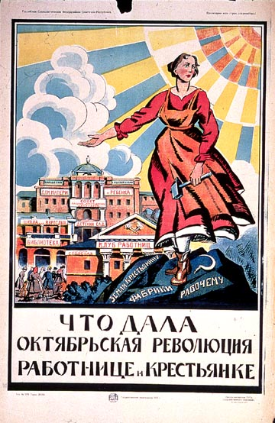

There were definite limits to the reform and equality achieved…the big plans of feminist revolutionaries like Alexandra Kollantai were ultimately deferred. And everyone was affected by political repression and an economy of shortages. But most women worked outside the home and had children, decades before this became common across classes in the U.S. By the 1990s:

Despite the changes wrought by glasnost, Russian women do not accept the feminist notion of total equality between the sexes or the need for women to do everything men do. “In Russian, the word feministka is a pejorative, meaning a bossy man-hater”…Though the younger generation is starting to think in terms of real career opportunities, making big money and working abroad, many Russian women still dream of staying home and being cared for by a strong and competent man. The writer Tatyana Tolstaya commented that while the American feminists were fighting for the right to work in coal mines, Russian women were fighting not to do so. Lynn Visson (1998)

In fact, some of them wouldn’t mind becoming American trophy wives…
www.loveme.com

So what did these kinds of differences in cultural/political/historical positioning imply for feminism? Were global movements possible, desirable, or productive? Could they be equitable? I wanted to think about a feminism that could link women around the world; but also one that could recognize that to a Russian woman, high-quality makeup and domesticity might look a lot more like liberation than would “equal rights.”

Thinking about cross-cultural feminism for an independent study project, I found a (then, very current) article by feminist scholar Chandra Mohanty that spoke to many of my concerns of that moment. I excerpt it in detail here, because in going back to look at I realized that her discussion of the category “third world women” is directly relevant to some of our recent discussions about the category of “women.”

http://serendip.brynmawr.edu/sci_cult/courses/sexgender/f05/mohanty.doc

Chandra Mohanty, “Cartographies of Struggle: Third World Women and the Politics of Feminism” (1991)

The very notion of addressing what are often internally conflictual histories of third world women’s feminisms under a single rubric, in one…essay, may seem ludicrous—especially since the very meaning of the term feminism is continually contested…But just as we have chosen to foreground “third world women” as an analytical and political category in the title of this collection, I want to recognize and analytically explore the links among the histories and struggles of third world women against racism, sexism, colonialism, imperialism, and monopoly capital. I am suggesting, then, an “imagined community” of third world oppositional struggles. “Imagined” not because it is not “real” but because it suggests potential alliances and collaborations across divisive boundaries, and “community” because in spite of internal hierarchies within third world contexts, it nevertheless suggests a significant, deep commitment to what Benedict Anderson, in referring to the idea of the nation, calls “horizontal comradeship.”

…This, then, is what provisionally holds the essays in this text on “third world women and the politics of feminism” together: imagined communities of women with divergent histories and social locations, woven together by the political threads of opposition to forms of domination that are not only pervasive but also systemic. An example of a similar construct is the notion of “communities of resistance,” which…like “imagined communities,” is a political definition, not an essentialist one.

…while such imagined communities are historically and geographically concrete, their boundaries are necessarily fluid. They have to be, since the operation of power is always fluid and changing.

…What seems to constitute “women of color” or “third world women” as a viable oppositional alliance is a common context of struggle rather than racial or color identifications.

(What do you think of this as an answer to the problem of “categories” in feminism?)

Getting back to my own research:
My latest project is, in fact, on Russian-American matchmaking. There are some standard stereotypes here: the men must be anti-feminist or just losers if they are going all the way to Russia for exotic wives they’ll be able to keep under their thumbs. The women must be gold-diggers, willing to sell their souls and bodies for McDonalds and a Mercedes.

The reality, of course, is much more complicated. Why are we so sure that love found over the internet or through a “romance tour” to Russia can’t be as real as any other? If a marriage is “strategic,” does this make it morally bankrupt (and is this really so unusual anyway – remember Chapkis)? It has seemed to me very important to understand what reasonable motivations might be leading Russian women, and American men, to look for their spouses abroad. Women are being objectified on these websites, yes; but is that enough for a feminist analysis to say about this phenomenon? Why do people want to do this?? These are the kinds of questions I’ve begun to examine through ethnographic fieldwork (which I can talk about more if we have time).

Yet I do feel a good bit of ambivalence about this de-pathologizing approach, since this is a situation rife with risk and some of the marriages do go wrong. In empathizing with people’s personal stories of why they think this is a good idea, I don’t want to become an apologist for an industry that can have scary consequences.

http://serendip.brynmawr.edu/sci_cult/courses/sexgender/f05/BBC.doc

http://www.tahirih.org/tahirih/inaction/pubpol_advocacy.html

So, how to reconcile all this? I’m not sure, except to notice that I think my foremothers are telling me that to grasp these women’s shared “contexts of struggle” is to have greater insight into their agency (why do their choices make sense to them?) and the factors that shape and constrain it (what is the situation they are working within and against?).

…And of course, there is probably no one answer as to whether these women are making choices that are “good” or “bad” for them, by any objective or moral measure. As one of my favorite anthropologists, Lila Abu-Lughod,
http://www.columbia.edu/cu/anthropology/fac-bios/abu-lughod/faculty.html
writes (in “The Romance of Resistance,” 1989):

“If the systems of power are multiple, then resisting at one level may catch people up at other levels.”

Her example is that of Bedouin women in Egypt who are espousing images of “modern” womanhood and starting to wear western-style lingerie. Such practices reflect their increasing freedom from the confines of a traditional extended-family household structure (in which wives are subject to the control of their mothers-in-law). At the same time, the increased emphasis now placed on husband-wife intimacy (hence the lingerie) is making women more directly, narrowly dependent on their husbands. Abu-Lughod worries that in the name of increasing freedom, the women are “backing in” to new forms of subjection. Perhaps my “Russian ladies” are, similarly, both freeing themselves and catching themselves up?

A final thought from Mohanty as you work on your books:
…resistance accompanies all forms of domination. However, it is not always identifiable through organized movements; resistance inheres in the very gaps, fissures, and silences of hegemonic narratives. Resistance is encoded in the practices of remembering, and of writing…Coherence of politics and of action comes from a sociality which itself perhaps needs to be rethought. The very practice of remembering against the grain of “public” or hegemonic history, of locating the silences and the struggle to assert knowledge which is outside the parameters of the dominant, suggests a rethinking of sociality itself.

Return to Day 22,
and Anne’s story:
http://serendip.brynmawr.edu/sci_cult/courses/sexgender/f05/day22/

