**Food Webs, Energy Flow, Carbon Cycle, and Trophic Pyramids**[1]

**Wolves in Yellowstone National Park**

In the early twentieth century, humans eliminated wolves from Yellowstone. In the late twentieth century, humans brought wolves back to Yellowstone. You will learn how these changes in the wolf population affected the populations of other animals and plants in Yellowstone.

To begin, watch part of the “Ecosystems Video” (<https://www.learner.org/series/the-habitable-planet-a-systems-approach-to-environmental-science/ecosystems/ecosystems-video/>); begin at 13 minutes and 40 seconds (right when the video switches from a tropical ecosystem to Yellowstone) and end at 22 minutes (right after the researcher shows that tall willows escape browsing). An **ecosystem** includes the animals, plants and other organisms in an area and their physical environment.

The graphs summarize recent trends in the numbers of wolves and elk in the Northern Range in

|  |  |
| --- | --- |
| Yellowstone National Park.  **1.** Why did the number of elk decrease after 1995?  **2a**. Approximately how many wolves were there in 2010-2015?  **2b**. Approximately how many elk were there in 2010-2015? |  |

**2c.** Notice that the number of wolves is much lower than the number of elk. What is one possible explanation for this difference?

**3.** After wolves were eliminated from Yellowstone in the early twentieth century, willow growth decreased. What is a likely explanation for this trend in willow growth?

**4a**. Beavers use tall willows for food and building dams. Predict the change in the number of beavers when wolves were eliminated from Yellowstone.  decreased ___ increased ___

**4b**. Explain your reasoning.

We will return to these questions as you learn more during this activity.

**Food Chains and Food Webs**

|  |  |
| --- | --- |
| A **food chain** summarizes a sequence of trophic relationships. **Trophic** means eating or nutrition. As shown in this figure, producers (plants) are eaten by primary consumers (herbivores), and primary consumers are eaten by secondary consumers (predators). |  |

**5a.** To show a specific food chain, write grass, rabbit and mountain lion in the appropriate blank boxes.

**5b**. Primary consumer and herbivore are different names for an animal that eats ­­­___________.

**5c.** Each arrow in a food chain points from an organism that ______________________ to an organism that _____________________ .

There is another type of food chain that doesn’t begin with living plants. Think about a 100-year-old forest where the leaves have dropped from the trees each fall, dead branches have fallen, and animals have died each year. But, you won’t see 100 years of dead stuff piled up on the ground in the forest.

**6**. What do you think has happened to all the dead stuff?

**Decomposers** get their nutrition from dead organic matter. Two major types of decomposers are bacteria and fungi (e.g. mushrooms). These bacteria and fungi secrete digestive enzymes into dead organic matter and absorb digested molecules. Thus, all the dead stuff is eventually digested.

|  |  |
| --- | --- |
| The first flowchart on the right shows a food chain that begins with dead organic matter. The second flowchart shows an example of this type of food chain in Yellowstone.  **7**. If you visited Yellowstone, you might not notice this food chain. Why not? |  |

**8**. Match each item in the left list with the best match or matches from the right list.

Producer ___ a. an animal that eats plants

Primary consumer ___ ___ b. an organism that consumes dead organic matter

Secondary consumer ___ ___ c. an organism that eats primary consumers

Decomposer ___ d. an organism that eats producers

e. an organism that makes its own organic molecules from

small inorganic molecules (e.g. uses photosynthesis to

make sugars from CO2 and H2O)

f. includes some predators and Protista

In real biological communities, the trophic relationships are much more complex than a simple food chain. These more complex trophic relationships are summarized in a **food web**.

|  |  |
| --- | --- |
| This figure shows a small part of a food web. Notice that the food web contains multiple food chains.  **9.** Use asterisks (*) to mark the organisms in one food chain in this food web.  Most of the organisms in this food web can be classified in one of these **trophic levels**:   * producers * primary consumers * secondary consumers. |  |

However, not all organisms fit in a single trophic level. You may have heard of omnivores which eat both plants and animals. A more general category is a **trophic omnivore** which is any animal that eats organisms from more than one trophic level.

**10**. In the above figure, use one of the following symbols to label each type of organism.

P = Producer (There are 2 of them.)

PC = Primary Consumer (3)

SC = Secondary Consumer (2)

TO = Trophic Omnivore (3; any animal that eats trophic omnivores is a trophic omnivore.)

**Trophic Relationships in Yellowstone**

Your teacher will give you a deck of cards that you will use to make a Yellowstone food web. In the procedure below, complete each step and check the box before beginning the next step.

1. To begin, draw the rectangles in this chart on your lab table or on the large paper provided by your teacher. Each rectangle should be big enough for the number of cards shown. Be sure to leave space for trophic omnivores between and above the two sets of rectangles.

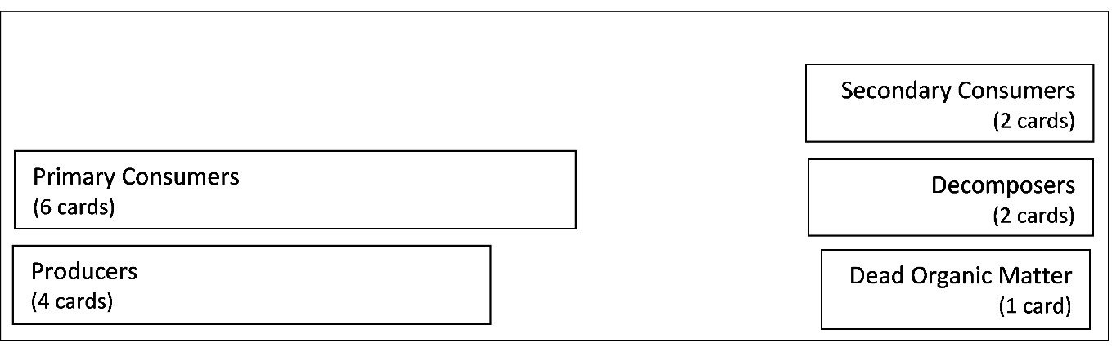

1. Find the cards for the producers and dead organic matter in your Yellowstone deck. Put these cards in the appropriate rectangles.
2. Find the cards for the primary consumers (which eat only producers) and the decomposers (which consume only dead organic matter). Put these cards in their rectangles. Draw an arrow to show each trophic relationship listed on the cards.
3. Use the remaining cards to put the secondary consumers in their rectangle and the trophic omnivores in appropriate places outside the rectangles. (Any animal that eats trophic omnivores is also a trophic omnivore.) Draw an arrow to show each trophic relationship.

Your Yellowstone food web may look complex, but a complete Yellowstone food web would be much more complex. Here are some causes of this additional complexity.

* Many more types of organisms live in Yellowstone, including more than 1000 different kinds of plants and more than 1000 different kinds of insects.
* The trophic relationships are more complex than is shown in your food web. For example, when an elk is killed by a pack of wolves, the wolves eat much of the meat, but some of the rest is eaten by other animals such as bears, coyotes, eagles and ravens. After animals have finished eating, the remaining dead organic matter is consumed by decomposers.
* Some of the trophic relationships shown are much more important than others. For example, Yellowstone wolves eat many elk and few beavers.

**11a.** To add a little of this complexity to your food web,make the arrow from elk to wolves fatter to represent the importance of this trophic relationship.

**11b.** Draw arrows from the producers and primary consumers to dead organic matter. These arrows will represent the general point that, every year, many plants and animals become dead organic matter.

**12.** Your teacher may suggest improvements for your food web. After you make any suggested improvements, take a picture of your food web to submit to your teacher.

Even though your food web is incomplete, it can help you to predict and understand important

|  |  |
| --- | --- |
| ecological phenomena.  A **trophic cascade** occurs when a change in the size of a predator population has indirect effects on the size of another population in the ecosystem.  **13.** As shown in this figure, wolves reduce the number of elk, and elk reduce the number and size of willow shrubs. Show the indirect effect of wolves on the willow population with a curved arrow and (+) or (-) to indicate whether increases in the number of wolves result in increased or decreased willow growth. |  |

**14**. After wolves were eliminated from Yellowstone, the number of beaver colonies decreased. What is a likely explanation? (Hint: Remember that beavers use tall willows for building dams and for food.)

**Carbon Cycles and Energy Flow through Ecosystems and the Biosphere**

|  |  |
| --- | --- |
| The biosphere includes all of the Earth’s organisms. Life in the biosphere depends on a continuous inflow of energy from the sun.  **15a.** Suggest a hypothesis to explain why life in the biosphere needs a continuous inflow of energy.  **15b.** Life in the biosphere requires carbon atoms. However, the |  |

biosphere does *not* receive an inflow of carbon atoms. Suggest a hypothesis to explain how life in the biosphere continues without an inflow of carbon atoms.

To better understand why the biosphere needs an inflow of energy, but not carbon atoms, we need to review three biological processes that transform energy and carbon-containing molecules.

|  |  |
| --- | --- |
| In **photosynthesis**, plants use the energy from sunlight to make sugar molecules from CO2 and H2O. | The upper box shows changes in how the atoms are organized in molecules. The lower box shows the associated energy changes. |

**16a.** Circle the sugar molecule (glucose) in the chemical equation for photosynthesis.

**16b.** Explain how photosynthesis illustrates the following general principle.

Atoms are neither created nor destroyed in biological processes.

**16c.** Explain how photosynthesis illustrates the following general principles.

Energy is neither created nor destroyed in biological processes, but energy can be transformed from one type to another. During energy transformations and transfers, some of the input energy is transformed to heat energy.

|  |  |
| --- | --- |
| These equations summarize how **cellular respiration** produces ATP.  **17a.** Why do cells need ATP? |   The curved arrows represent coupled chemical reactions; the  top reaction provides the energy needed for the second reaction. |

**17b**. How does glucose contribute to the production of ATP?

**17c.** What process produces the glucose that plant cells use for cellular respiration?

**Biosynthesis** makes the many different types of organic molecules in an organism. Biosynthesis in plants uses some of the sugar molecules produced by photosynthesis, plus minerals from the soil. Animals and decomposers use digested food molecules as inputs for biosynthesis.

In a **carbon cycle**, carbon atoms cycle between CO2 in the air and organic molecules in living organisms or in dead organic matter. The figure below shows a carbon cycle that includes a simple food chain. Questions 18-19 will help you understand how photosynthesis, cellular respiration, and biosynthesis contribute to carbon cycles.

|  |  |
| --- | --- |
| **18a.** The B arrow shows CO2 entering a plant. How do the carbon atoms in CO2 become carbon atoms in organic molecules in the plant? |  |

**18b**. The A arrows show CO2 leaving the plant, animal and decomposers. How do carbon atoms in the organic molecules of plants, animals and decomposers become carbon atoms in CO2?

**18c.** The C arrow leads to dead organic matter via death or feces. Add another C arrow to show part or all of the tree dying and becoming dead organic matter.

**19a**. In the figure, circle the letters for the arrow from the giraffe and the arrow to the tree.

**19b.** Explain how a carbon atom in an organic molecule in a giraffe could become a carbon atom in an organic molecule in a tree. (Hint: Use the information in the figure and in your answers to questions 18a and 18b.)

**19c.** Explain how a carbon atom in dead organic matter could become a carbon atom in a giraffe.

|  |  |
| --- | --- |
| In this figure, energy flows have been added to the carbon cycle (see dashed arrows). This figure doesn’t show the energy transformations and transfers inside living organisms. For example, photosynthesis transforms light energy to chemical energy. Cellular respiration transfers chemical energy from sugars to ATP.  **20a.** Each energy transformation or transfer produces ________, which is radiated away from the |  |

biosphere.

**20b.** Label each dashed arrow in the above figure with one of these abbreviations:

**S** = arrow that shows the inflow of light energy from the sun.

**CE** = arrows that show chemical energy moving from one trophic level to another.

**H** = arrows that show that biological processes produce heat, which leaves the organisms and ultimately is radiated out to space.

**21a.** Explain how the sun’s energy can be transformed and transferred to provide the energy that a giraffe uses to move. Be specific about the multiple steps that are required.

**21b.** In your answer to question 21a, underline at least three processes that produce heat.

|  |  |
| --- | --- |
| **22a.** Explain why life in the earth’s biosphere needs a continuous inflow of energy.  **22b.** How can life continue in the earth’s biosphere without an inflow of carbon atoms? |  |

**Trophic Pyramids**

When you walk in a park or nature, you will see lots of plants, some primary consumers like squirrels, and very few predators like hawks. This activity will help you understand why plants are much more abundant than predators.

The **biomass** of an organism is the mass of all the organic molecules in the organism. A plant’s biomass is produced by photosynthesis and biosynthesis. However, not all the sugar molecules produced by photosynthesis become part of the plant’s biomass. This flowchart shows why.

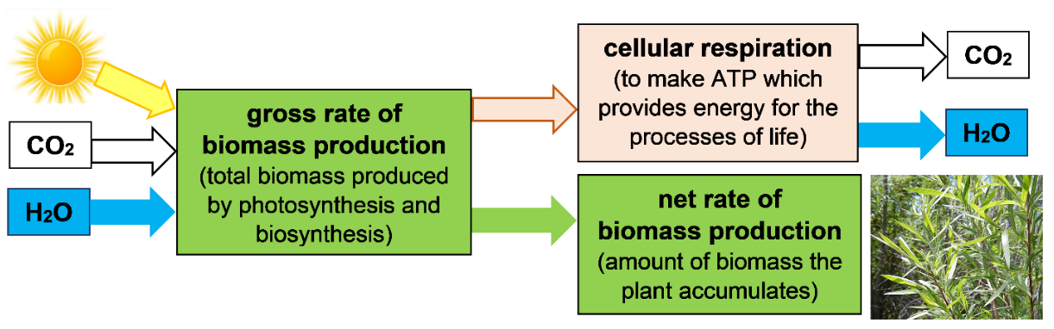

**23.** What happens to the sugar molecules produced by photosynthesis that do not become part of the plant’s biomass?

**24a.** Which rate of biomass production describes the rate that biomass becomes available as food for primary consumers to eat?

gross rate of biomass production ___ net rate of biomass production ­­­___

**24b**. Explain your reasoning.

The flowchart below shows what happens when plant biomass is eaten by a primary consumer. Some food molecules are not digested and instead pass through the consumer’s digestive system to be excreted in the feces; obviously, those molecules can’t contribute to the consumer’s biomass. Some digested food molecules are used for cellular respiration, so these molecules also do not contribute to the net rate of biomass production for primary consumers.

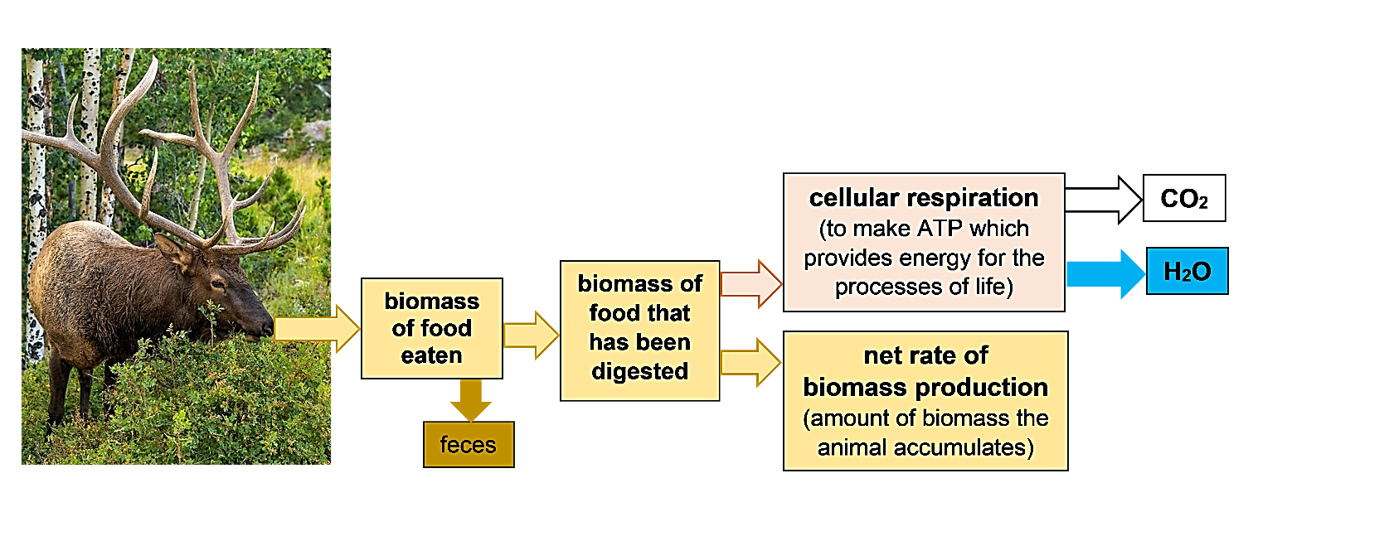

**25**. This flowchart shows two reasons why the net rate of biomass production for a consumer is less than the biomass of the food eaten by the consumer. Circle each reason.

**26**. Researchers evaluated the net rate of biomass production at different trophic levels in a forest in New Hampshire. The relative size of the boxes in this flowchart indicates the relative magnitude of the net rate of biomass production for the producers, primary consumers, and decomposers. Notice that the net rate of biomass production is lower for the primary consumers plus decomposers than for the producers. Add to this flowchart to show two reasons why. (Hint: See bottom of the previous page.)

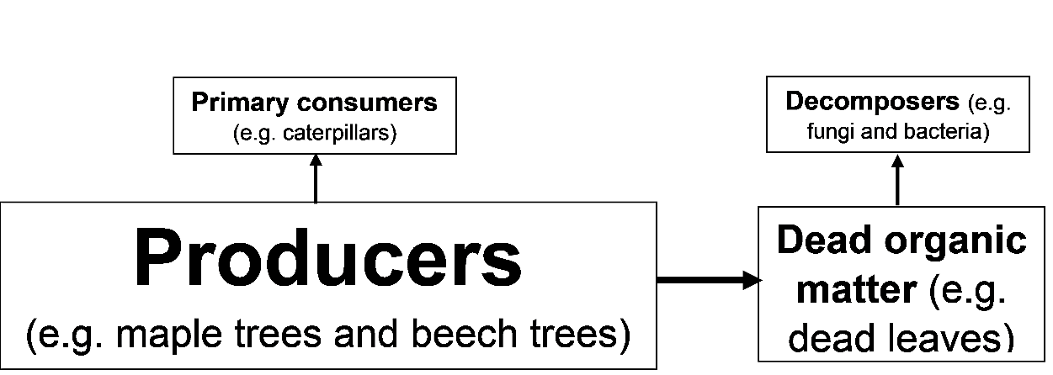

**27a.** The left column of this table shows a summary food web for this forest. (Each trophic omnivore is classified in the consumer level of the main type of food it eats.) The right column lists the net rates of biomass production at each trophic level in this forest. Circle the only rate that would be possible for the secondary consumers in this forest.

|  |  |
| --- | --- |
|  | Net Rate of Biomass Production (g/m²/year) |
| Secondary consumers (e.g. birds) | 30? 200? 1000? |
| ↑ |  |
| Primary consumers + Decomposers | 200 |
| ↑ |  |
| Producers | 1000 |

**27b.** Explain your reasoning.

**27c.** The length of each bar in this graph shows the net rate of biomass production for the producers in the forest and for the primary consumers plus decomposers. Add to the graph to show the net rate of biomass production for the secondary consumers.

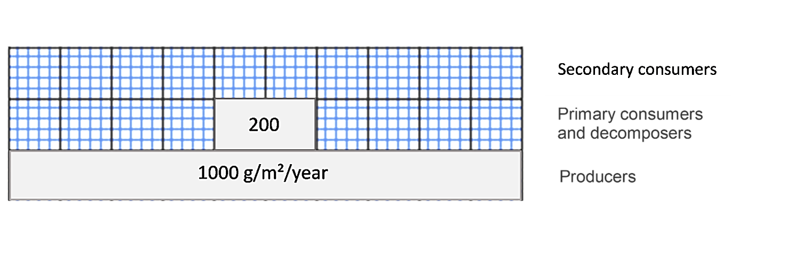

**27d**. Explain why animals that eat secondary consumers are very rare.

Information about the relative rates of biomass production at different trophic levels is often displayed in a **trophic pyramid** like this one.

Scientists sometimes use the general estimate that the net rate of biomass production for each trophic level is about 10% of the rate for the trophic level just below it.

**28a.** Use the 10% estimate to calculate the net rate of biomass production at each consumer trophic level in the above trophic pyramid.

**28b.** This 10% estimate is sometimes described as the 10% rule. What evidence from the forest ecosystem indicates that this 10% rule is not accurate in some cases?

**29.** It might be tempting to apply the 10% rule to estimate that there should be 10 times as many elk as wolves in Yellowstone. However, during the 21st century, there have been roughly 100 times as many elk as wolves. What is one possible reason why there is only one wolf for every 100 elk, instead of one wolf for every 10 elk? (Hint: See page 4 for information about other consumers of elk.)

**30a.** For lunch, Pat had a baked potato and Erin had a hamburger with no bun. They each consumed the same amount of biomass, but from different trophic levels. In comparison to the amount of land needed to produce Pat’s potato, how much land was needed to produce enough cattle feed to produce Erin’s hamburger?

1. roughly 10% as much land to produce enough cattle feed to produce the hamburger
2. roughly the same amount of land to grow the potato and the cattle feed
3. roughly 10 times as much land to produce enough cattle feed to produce the hamburger

**30b.** Explain your reasoning.

1. By Drs. Ingrid Waldron and Lori Spindler, Dept Biology, University of Pennsylvania. © 2024. This Student Handout and the Teacher Preparation Notes with instructional suggestions and background information are available at <http://serendipstudio.org/sci_edu/waldron/#ecolfoodweb> 